Functional Specification Document
  - OMEGA – Open Market Execution Gateway
  - Announcement
  - v0.02

Document Control
Revision History
Revision # | Release Date | Summary of Changes | Author
0.01 | 05 Dec 2025 | Initial draft. | Eugene Cheong
0.02 | 31 Dec 2025 | Specified options validation between the announcement and MEPS+ fails.  Specified handling for both secmast.txt and couponrates_sbond.txt validation for SSBs before changing the status of announcement.  Updated email distribution from specific user groups (FD/MDD users) to generic "distribution list users".  Modified UI field display from "Data Pair" to "read-only fields" for Viewers and Checkers.  Modified fields naming and added soft validations for date fields.  Added more details to calculate the step-up coupon rates.  Added additional wireframes to show differences based on security type, and also indicators for previous values and differences with MEPS+.  Enhanced modal functionality with Cancel buttons and closure descriptions  Modified fields to be shown in the PDF as well as display logic for certain fields. | Eugene Cheong

Reviewer Name (Designation) | Reviewed Version # | Date

Approver Name (Designation) | Approved Version # | Date

Table of Contents
1 Introduction 7
1.1 Purpose of Document 7
1.2 Scope 7
1.3 Definitions, Acronyms and Abbreviations 7
1.4 Reference 8
2 Functional Requirements 8
2.1 Purpose of Module 8
2.2 Actors 8
2.3 Process Diagrams 8
2.4 BPMN Workflow 10
2.5 State Transition Diagram 10
2.6 Use Cases 11
2.7 View Announcement 12
2.7.1 Description 12
2.7.2 Preconditions 12
2.7.3 Business Requirements 12
2.7.4 Post Conditions 12
2.7.5 Announcement Listing Page 12
2.7.6 Announcement Details Page 15
2.8 Update Announcements 32
2.8.1 Description 32
2.8.2 Preconditions 32
2.8.3 Business Requirements 32
2.8.4 Post Conditions 32
2.8.5 Announcement Details Page 33
2.8.6 Upload File Modal 34
2.8.7 Confirmation Prompt 35
2.9 Withdraw Announcement Approval Request 36
2.9.1 Description 36
2.9.2 Preconditions 36
2.9.3 Business Requirements 36
2.9.4 Post Conditions 36
2.9.5 Announcement Details Page 36
2.9.6 Confirmation Prompt 37
2.10 Approve/Reject Announcement/Unpublish Announcement 37
2.10.1 Description 37
2.10.2 Preconditions 37
2.10.3 Business Requirements 37
2.10.4 Post Conditions 38
2.10.5 Announcement Details Page 38
2.10.6 Confirmation Prompt 41
2.10.7 Unpublish Banner 42
2.11 Unpublish Announcement 42
2.11.1 Description 43
2.11.2 Preconditions 43
2.11.3 Business Requirements 43
2.11.4 Post Conditions 43
2.11.5 Announcement Details Page 43
2.11.6 Confirmation Prompt 44
2.12 Override MEPS+ Validation Error 44
2.12.1 Description 44
2.12.2 Preconditions 44
2.12.3 Business Requirements 44
2.12.4 Post Conditions 44
2.12.5 Announcement Details Page 45
2.12.6 Confirmation Prompt 45
2.13 Preview PDF 46
2.13.1 Description 46
2.13.2 Preconditions 46
2.13.3 Business Requirements 46
2.13.4 Post Conditions 46
2.13.5 Announcement Details Page 46
2.13.6 Preview PDF Modal 47
2.13.7 Sample Files 48
3 Other Announcement Fields Not In UI 48
3.1 Fields Based on Configurable Parameters 48
3.2 Fields Based on Static Text 48
4 Summary Email 49
5 Validations Against MEPS+ 50
6 Step-up Coupon Rate Calculation Logic 51
7 Fields for PDF Previews 53

Introduction

Purpose of Document
This Functional Specification Document is used to clearly define the intended functionality of OMEGA.
OMEGA is a platform that supports MAS’ central banking functions related to market operations and benchmark administration. OMEGA aims to improve business efficiency by leveraging on technology and design thinking, minimising manual intervention, re-engineering business processes and improving system resiliency.
OMEGA consists of several modules. This document outlines the functionality of the Bonds and Bills module, focusing on features, functions, and behaviour specifically for announcements, without detailing how these functionalities will be technically implemented. It aims to:
- Establish a shared understanding of the system's functional scope;
- Provide a clear and unambiguous description of each functional requirement;
- Ensure that the developed system meets the identified business needs and user expectations;
- Facilitate effective communication and collaboration among all project stakeholders;
- Serve as a baseline for system development, testing, and implementation; and
- Manage and control changes to the system's functionality through a defined change management process.

Scope
The Bonds and Bills module allows MAS internal users to perform the following functionalities:
- Update announcements;
- Submit announcements for approval or withdraw submissions;
- Approve announcements as part of the maker-checker process;
- Publish or unpublish announcements;
- Override with the data from MEPS+; and
- Preview announcement PDFs.
This document excludes announcements for syndication, which will be documented in MAS_OMEGA – Functional Specifications Document (Syndication).docx instead.

Definitions, Acronyms and Abbreviations
Acronym | Description
BPMN | Business Process Model and Notation
CDP | Central Depository Pte Limited
FI | Financial Institution
ISIN | International Securities Identification Number
MAS | Monetary Authority of Singapore
MEPS+ | MAS Electronic Payment System+
OMEGA | Open Market Execution Gateway
PD | Primary Dealer
PDF | Portable Document Format
SFTP | Secure File Transfer Protocol
SGS | Singapore Government Securities
SSB | Singapore Savings Bonds
Table 1: Acronyms used in document

Reference
The following documents are referenced throughout this functional specification and should be consulted for additional context, detailed requirements, and technical information that supports the functional requirements described in this document.
- Logic for Issue Code.pdf
- MAS_OMEGA – Interface Specifications Document (MAS Website).docx
- MAS_OMEGA – Functional Specifications Document (Common Functions).docx
- MAS_OMEGA – Functional Specifications Document (Administration).docx
- MAS_OMEGA - Interface Functional Specifications Document (MEPS+, FMBS and AGD).docx

- MAS_OMEGA – Additional Information (Error Messages).xlsx – This file contains a list of validations in each module and their corresponding error messages.
- MAS_OMEGA – Additional Information (System Notifications and Emails).xlsx – This file contains a list of system notifications and emails in each module and their corresponding content.

Functional Requirements

Purpose of Module
MAS internal users can manage announcements and their publication to the MAS website.
OMEGA contains outbound interfaces to the MAS website to send over the necessary information for the publication of announcements. OMEGA also contains inbound interfaces from MEPS+ to receive the security information upon its creation, as well as to receive the coupon rates for SSBs. In addition, notifications in the form of emails and/or system notifications are available.

Actors
The actors identified for this module are as follows:
Actors | Description
Announcement Maker | The entity responsible for updating announcements.
Announcement Checker | The entity responsible for approving the update or unpublishing of announcements.
Announcement Viewer | The entity who is only allowed to view announcements and preview the announcement in PDF.
Table 2: Actors of module

Process Diagrams
The figure below shows the high-level activities when updating an announcement:
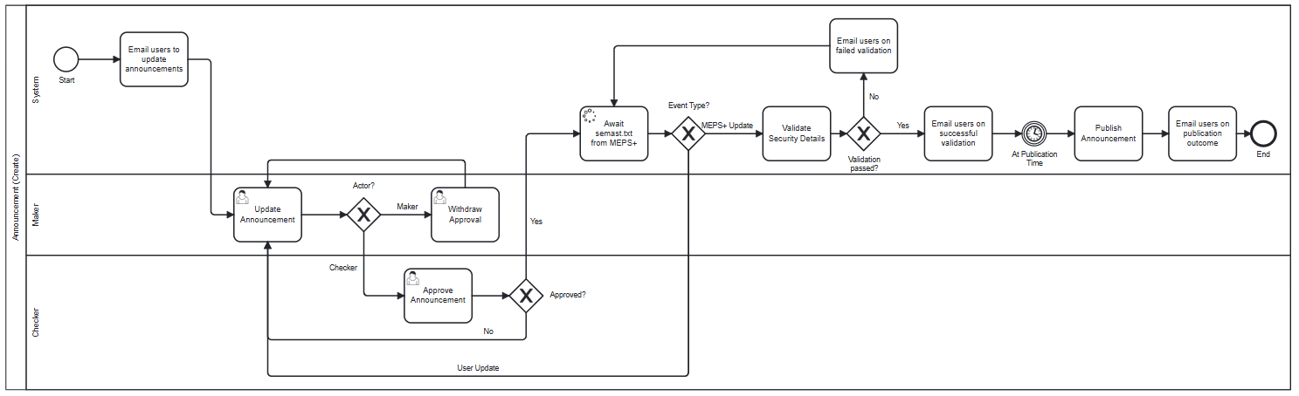
Figure 1: Activities when updating an announcement
On announcement date (identified through the issuance calendar), OMEGA creates the announcement record for the Maker to update, with the status as New. This system-initiated announcement record is not persisted in the database, i.e. when Maker clicks into the record and navigates away, OMEGA does not store the record yet. When updating an announcement, some of the fields are pre-filled based on the data from the issuance calendar and the parameter settings. Fields which are blank and marked with an asterisk have to be updated by the Maker before being submitted for approval.
Upon submission, the Checkers can view the announcement and determine whether to approve or reject it. If the announcement is rejected, the announcement is sent back to the Maker for edits.
If the announcement is approved, OMEGA sends an email to notify users in a distribution list to create the security in MEPS+ and waits to receive the secmast.txt file from MEPS+. Upon receiving the file, OMEGA processes the file and validates any announcements with status as pending the security to be created from MEPS+ (“Pending MEPS+”), against the data in secmast.txt. If the validations fail, an email is sent to notify users of the failed validations, so that users can address the reason(s) for failed validation accordingly. There will be 3 possible courses of action::
- Overwrite the data in OMEGA with data from MEPS+; or
- Amend the security details in MEPS+ and re-send the secmast.txt file into OMEGA; or
- Update the announcement in OMEGA.
For options 2 and 3, OMEGA will do another round of processing and validation of the secmast.txt file. Refer to MAS OMEGA – Interface Functional Specifications Document (MEPS+, FMBS and AGD).docx for the validations made within the secmast.txt..
For SSBs, apart from security details in the secmast.txt file, the coupon rates are sent from MEPS+ via couponrates_sbond.txt and are to be validated against the step-up coupon rates in the announcement. Refer to MAS_OMEGA - Interface Functional Specifications Document (MEPS+, FMBS and AGD) v0.01.docx for the validations made within the couponrates_sbond.txt. If only one of the two files are validated, the status of the announcement will remain at “Pending MEPS+” until the other file is validated.

If the validations pass, an email is sent to users informing that the validation of the announcement against secmast.txt is successful. Another email is sent to users when the announcement is published to the MAS Website based on the publication timing selected.
These emails could be configured to be sent to different MAS user groups (e.g., the email for the successful validation against secmast.txt could be sent to FD while the email for the announcement publication could be sent to MDD). Refer to MAS_OMEGA – Functional Specifications Document (Administration).docx for the configuration.

BPMN Workflow
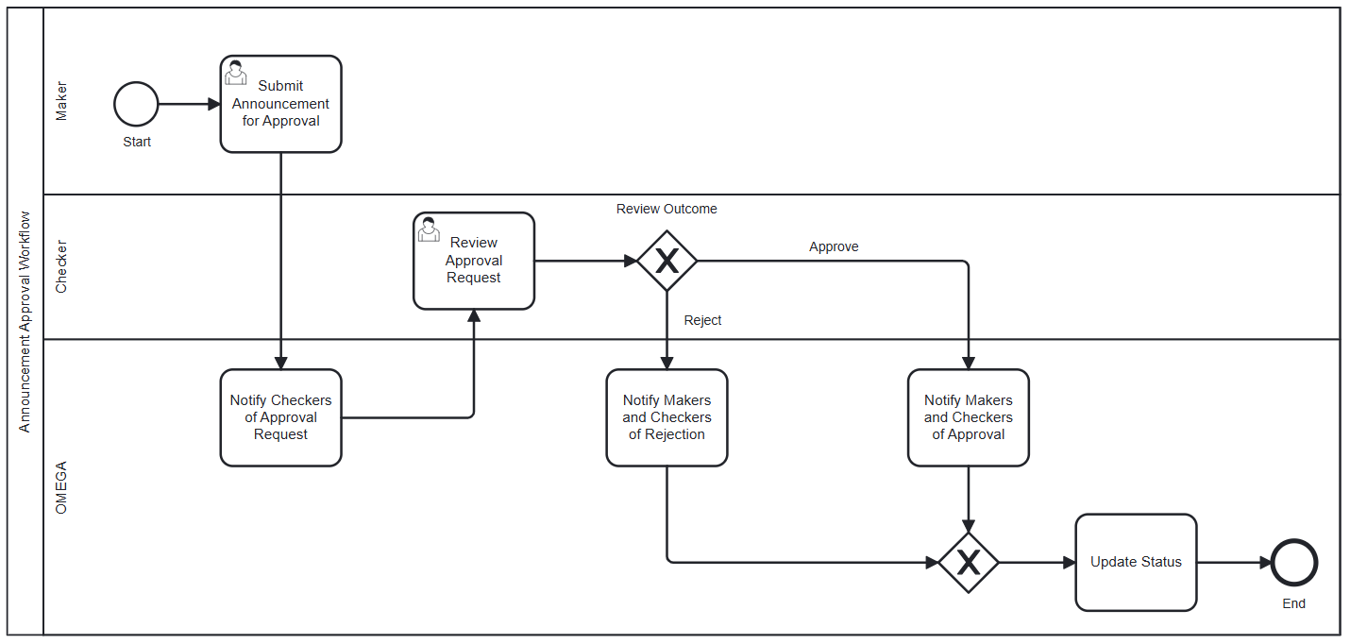
Figure 2: BPMN workflow for announcements
In this module,
- An instance of the BPMN workflow above is created when a Maker submits an announcement for approval.
- When an announcement is submitted for approval, OMEGA notifies the Checkers of the approval request that is pending their review.
- The Checker reviews the announcement approval request with the option to approve or reject the request.
- When approved, the Makers and the Checkers are notified of the approval, and OMEGA updates the status of the announcement to “Pending MEPS+”. OMEGA then waits to receive the security information via secmast.txt, and couponrates_sbond.txt for SSBs.
- When the request is rejected, the Makers and the Checkers are notified of the rejected request, and OMEGA reverts the status of the announcement to its previous status; unless at “Pending Publication”, the status is shown as “Rejected”. No changes to the announcement are published on the MAS Website until the announcement is updated, approved, and validated against the information in secmast.txt (and couponrates_sbond.txt for SSBs) again.

State Transition Diagram
The figure below shows the possible status transitions that an announcement may undergo, and the conditions required to trigger these transitions.

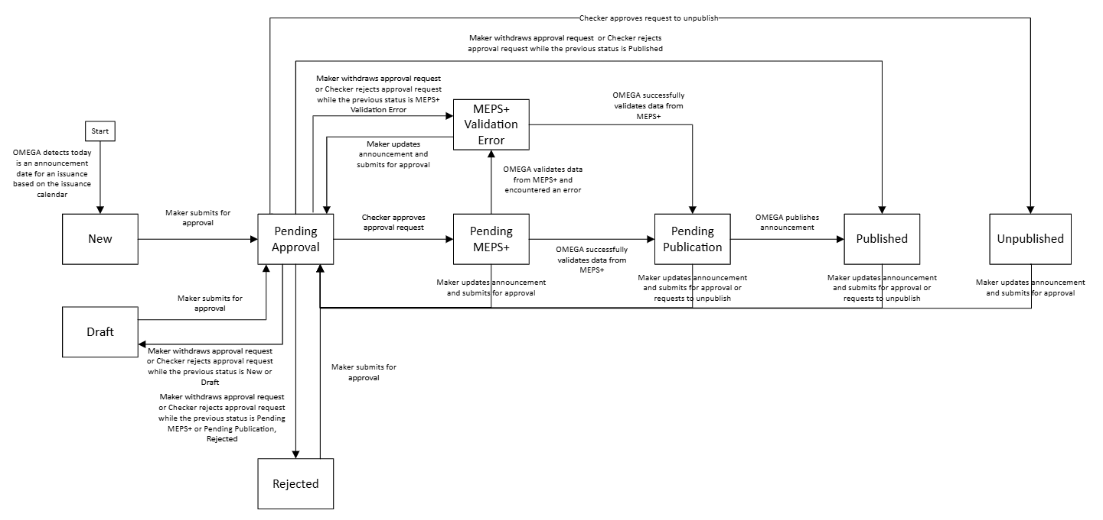
Figure 3: State transition diagram

Use Cases
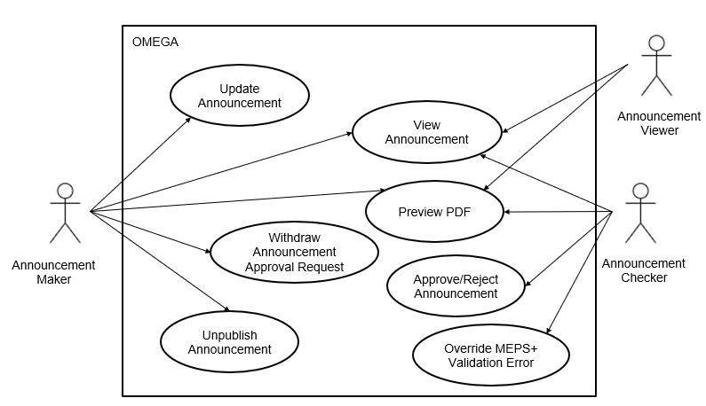
Figure 4: Use case diagram
The use cases covered within this module are:
- 2.7 View Announcement
- 2.8 Update Announcements
- 2.9 Withdraw Announcement Approval Request
- 2.10 Approve/Reject Announcement/Unpublish Announcement
- 2.11 Unpublish Announcement
- 2.12 Override MEPS+ Validation Error
- 2.13 Preview PDF

View Announcement

Description
This use case enables users to view and filter announcements.

Preconditions
- User logs in to the Intranet Portal.
- User accesses the Announcement Listing Page.

Business Requirements
- Role-based Access Control:
  - Announcement Maker
  - Announcement Checker
  - Announcement Viewer
- Pre-population of Data from Issuance Calendar: If the status of the announcement is “New”, the details in the Announcement Listing Page and the Security Information section of the Announcement Details Page are pre-populated from the latest approved issuance calendar (i.e., any updates to the calendar will be reflected in real-time), and the Last action by and Last action on columns In the Announcement Listing Page will display “-“.For all other statuses, the details are instead retrieved from the announcement database table.

Post Conditions
- User views the announcement details for a particular issuance.

Announcement Listing Page
The Announcement Listing Page contains the following screen elements:
- Page Header
- Data Table Action Bar
- Filter Drawer
- Data Table
Default Sorting: (1) descending order of announcement date, (2) ascending order of security type, then (3) ascending order of tenor.
Default Filter: Only show records whose announcement date is the current date.
Custom Filter Tag Behaviour: When the default filter is used, the From and the To fields in the Data Table Action Bar display the current date as well as a tag . This tag is not closable by users. If any other date ranges are used, the tag is replaced with another tag . This tag is closable by users. If closed, the date filter is reset to show the default filter.

Wireframe

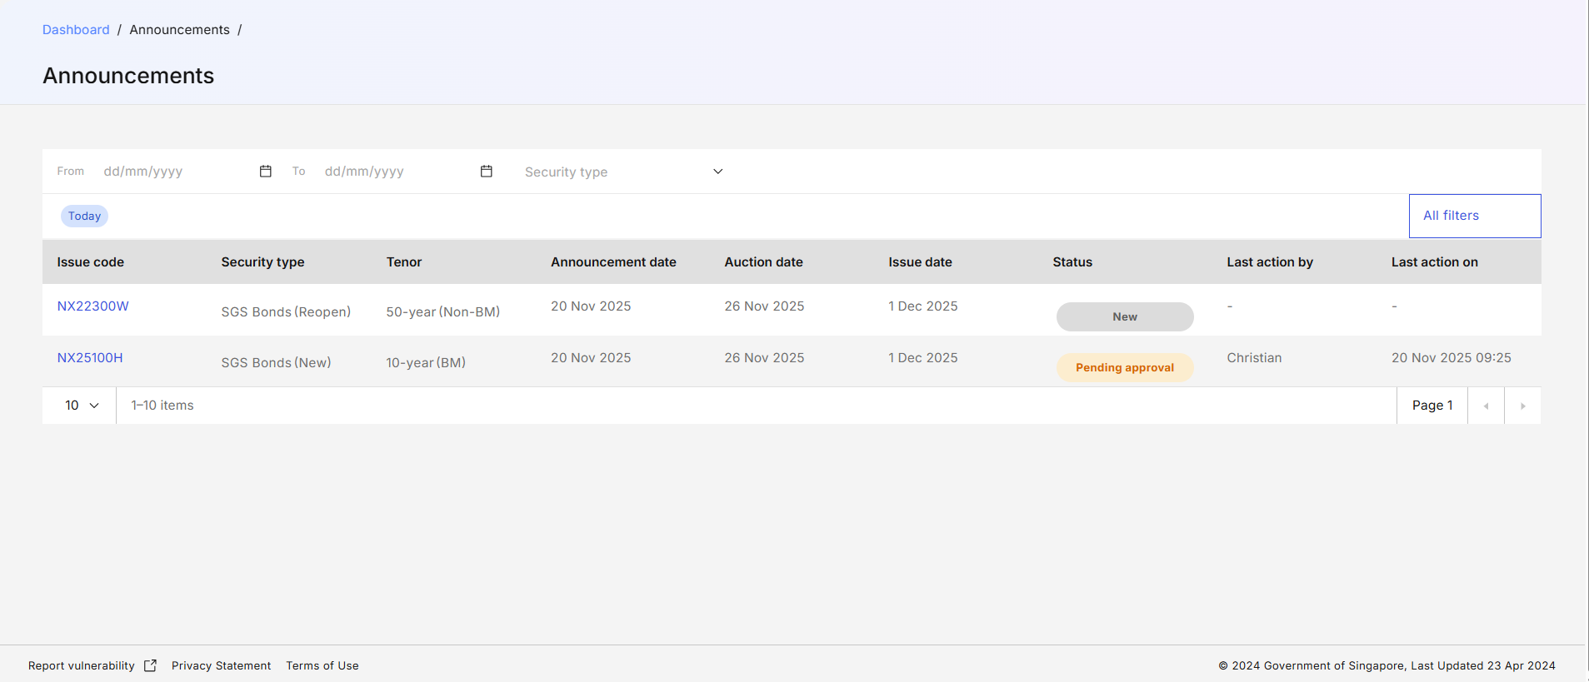
Figure 5: Announcement Listing Page

Page Header
S/N | Name | Type  (Max Length) | Validation Rules | Remarks
1 | Home / Announcement / | Breadcrumb
2 | Announcement | Page title
Table 3: Page Header Screen Elements

Data Table Action Bar
S/N | Name | Type  (Max Length) | Validation Rules | Remarks
1 | Announcement from | Date Picker |  | To filter for Announcement date. The date selected is inclusive.
2 | To | Date Picker |  | To filter for Announcement date. The date selected is inclusive.  Earliest allowed date is the value of the From field. Latest allowed date is today.
3 | Security type | Multiselect Dropdown |  | Options available are:  - SGS Bonds  - MAS Bills  - T-Bills  - SSBs  - CMTBs  Additional options are available based on the name when new security types are created.
Table 4: Data Table Action Bar Screen Elements

Filter Drawer
S/N | Name | Type  (Max Length) | Validation Rules | Remarks
1 | Announcement date | Date Picker |  | Contains two date pickers: From and To.
2 | Security type | Checkbox Group |  | Same options as Security type in Data Table Action Bar.
3 | Status | Checkbox Group |  | “New” is not an available option for this filter category. Refer to 2.5 State Transition Diagram for the list of other available options.
Table 5: Filter Drawer Screen Elements
Refer to MAS_OMEGA – Functional Specifications Document (Common Functions).docx for the common screen elements and functionalities used in the Filter Drawer.

Data Table
S/N | Name | Type  (Max Length) | Validation Rules | Remarks
1 | Issue code | Label (with hyperlink) |  | Clicking on the hyperlink navigates the user to the Announcement Details Page based on the issue code and issue date of the row.
2 | Security type | Label |  | For SGS bonds, after the security type, add “(New)” or “(Reopen)” depending on whether the New/Reopen field value in Security Information is “New” or “Reopen”.
3 | Tenor | Label |  | For SGS bonds, after the tenor, add “(BM)” or “(Non-BM)” depending on whether the Benchmark field value in Security Information is “Yes” or “No”.
4 | Announcement date | Label
5 | Auction date | Label
6 | Issue date | Label
7 | Status | Label |  | Refer to 2.5 State Transition Diagram for the possible values.
8 | Last action by | Label |  | Display the name of the user who made the last action that resulted in a change of status.  If it was an update by the system, “OMEGA” would be reflected as the user.
9 | Last action on | Label |  | Display the date and time of the last action that resulted in a change of status.
Table 6: Data Table Screen Elements

Announcement Details Page
The Announcement Details Page contains the following screen elements:
- Page Header
- Submission History
- Security Information
- Offering Details
- Coupon & Interest
- Coupon payment dates
- Footnotes
- Publication Details
- Internal Remarks
- Action Button Row
For Viewers and Checkers, the fields in the Security Information, Offering Details, and Coupon & Interest sections are displayed as read-only fields.

Wireframe
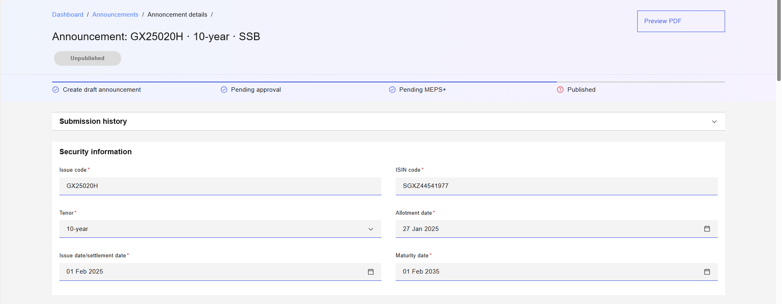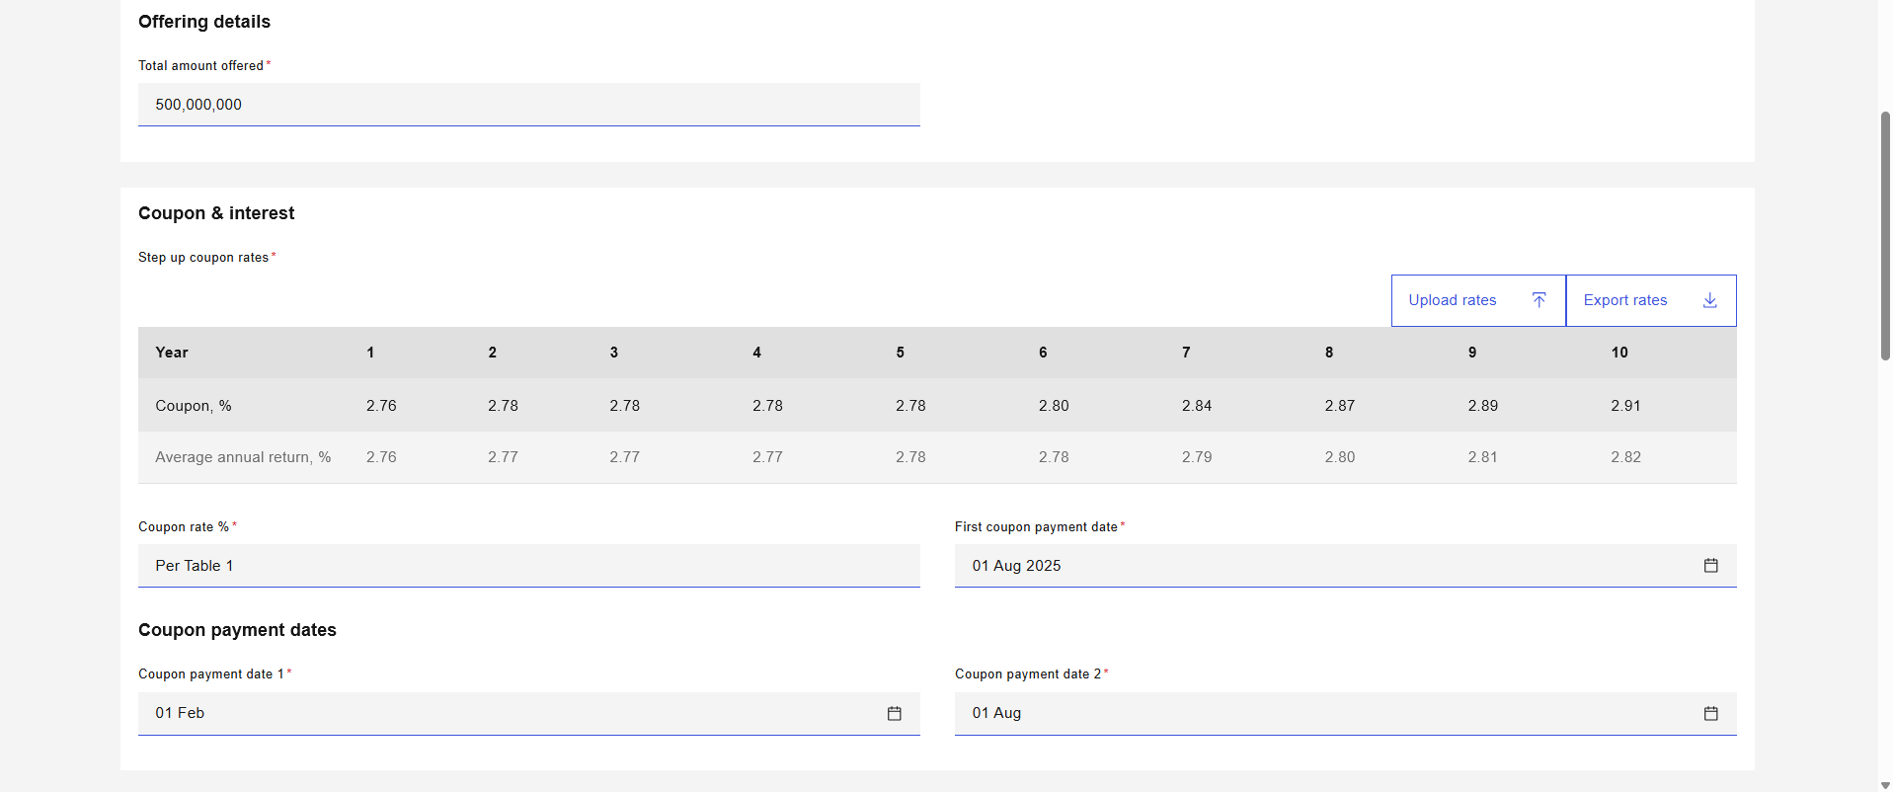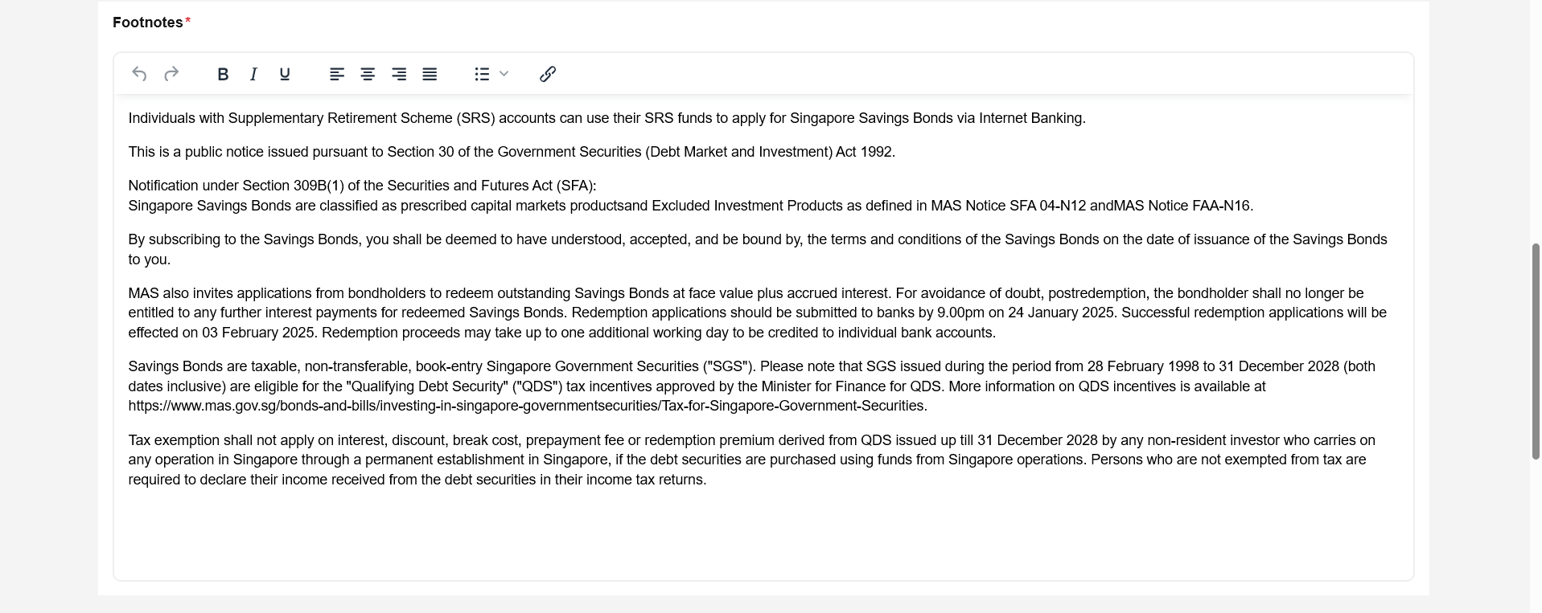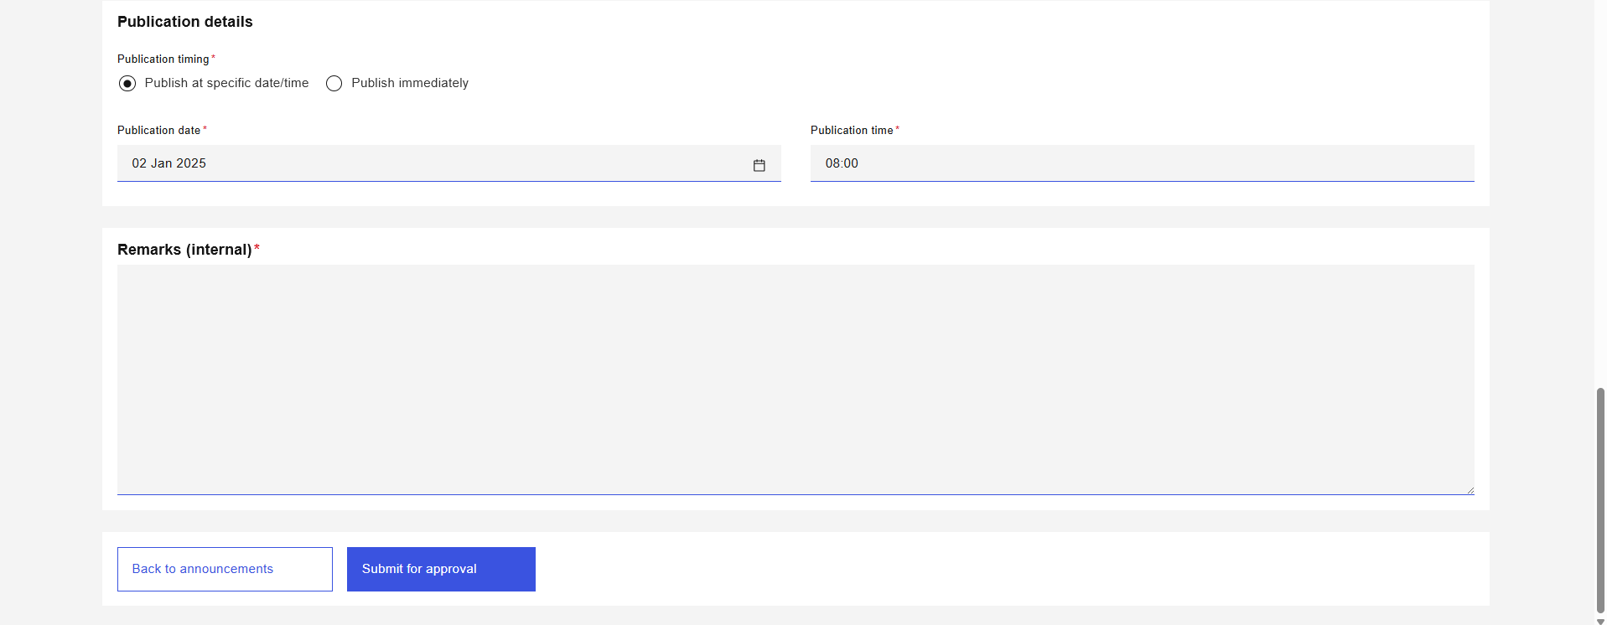
Figure 6: Announcement Details Page (SSBs)
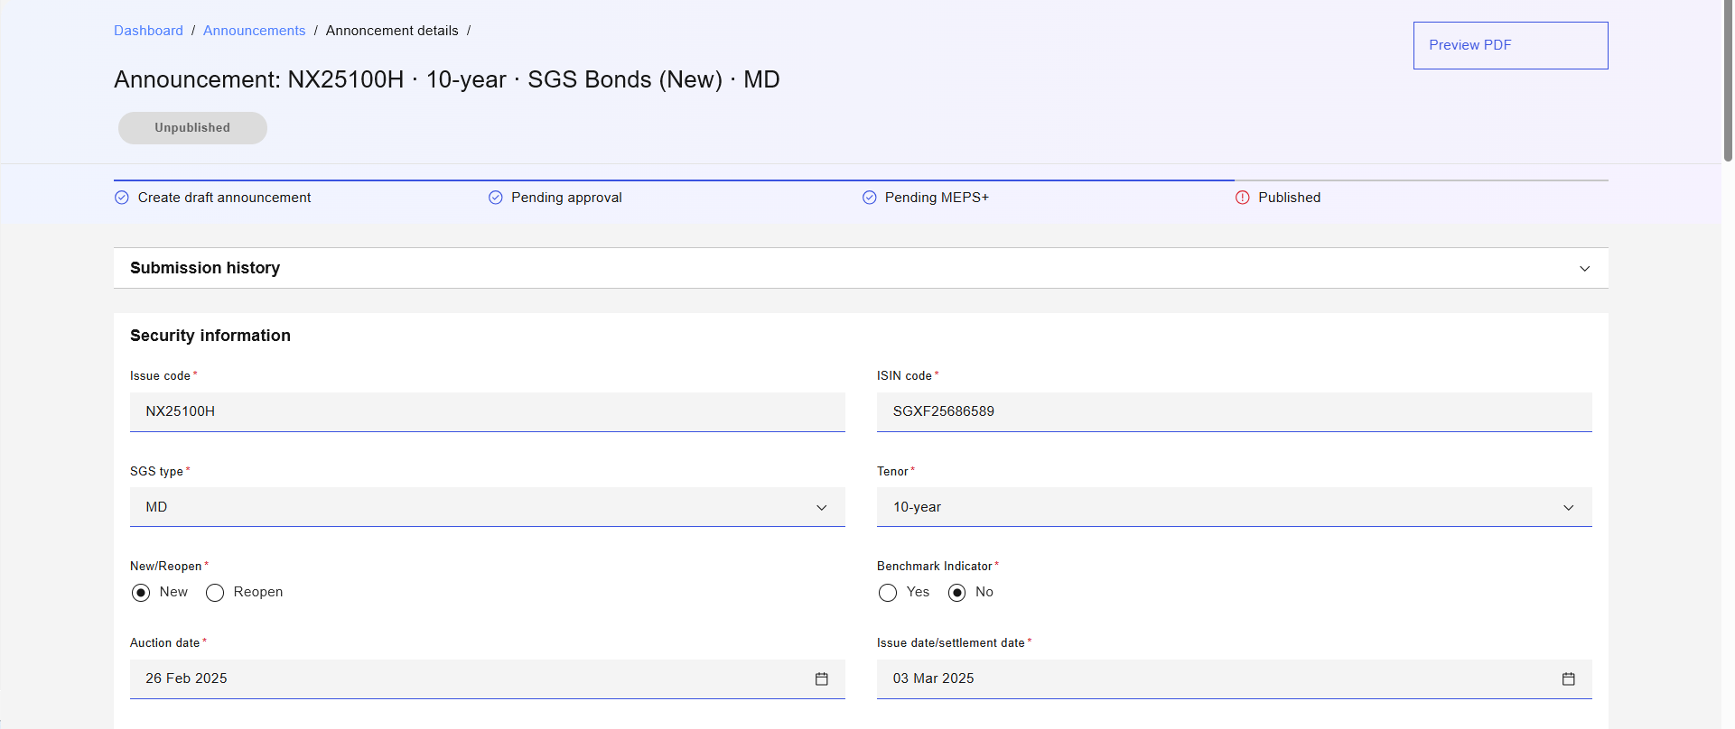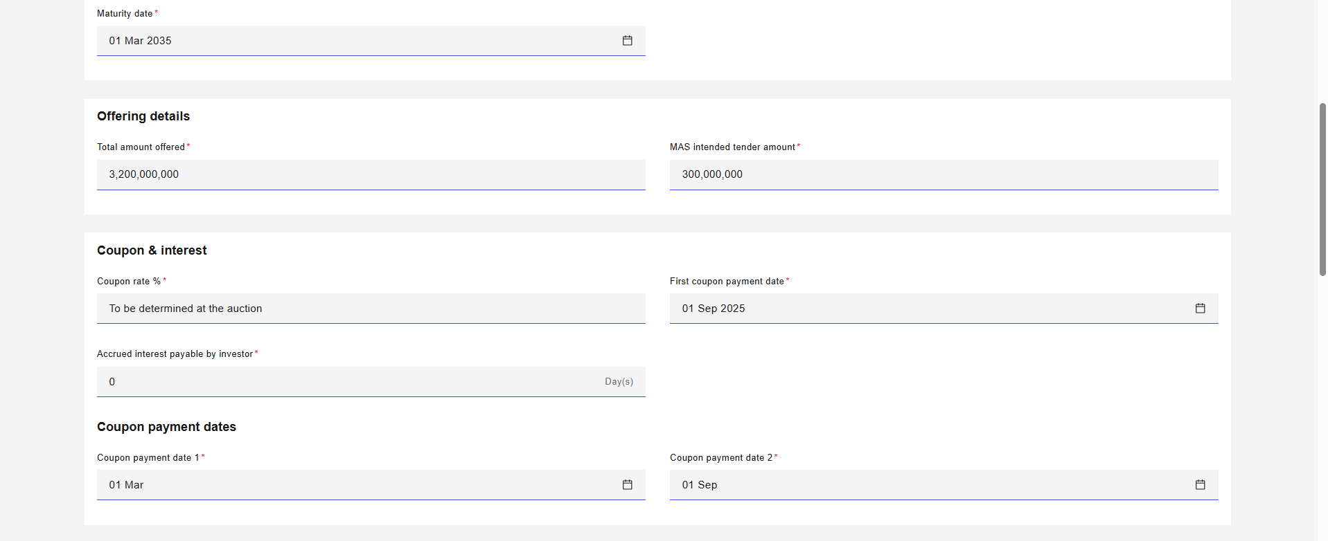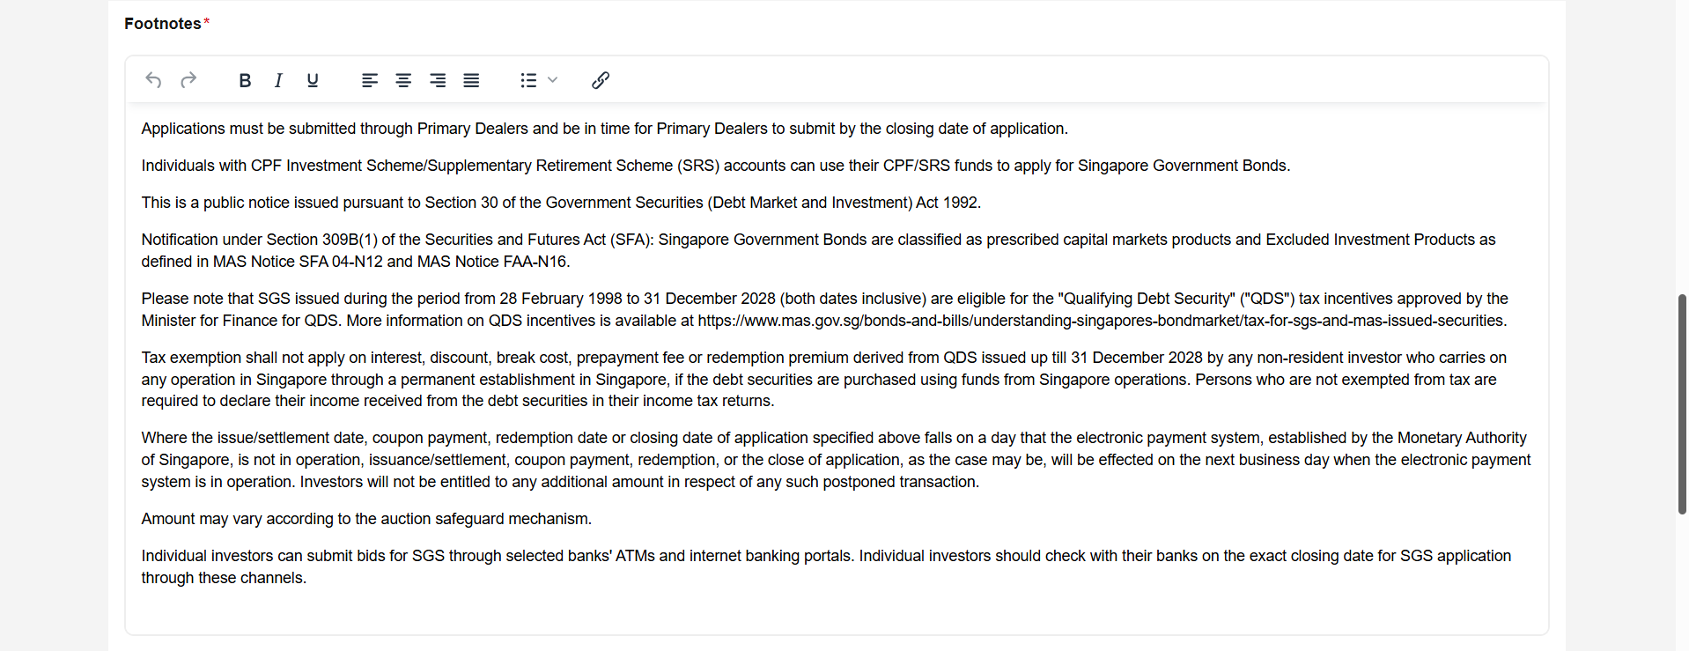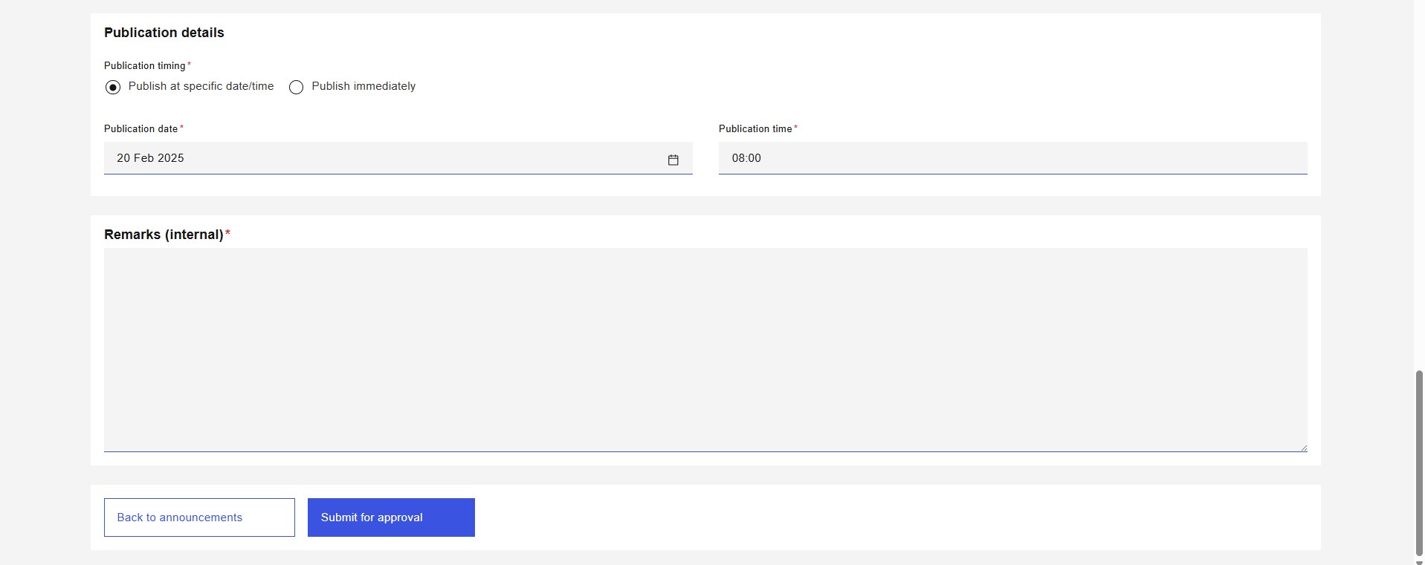
Figure 7: Announcement Details Page (SGS Bonds – New)

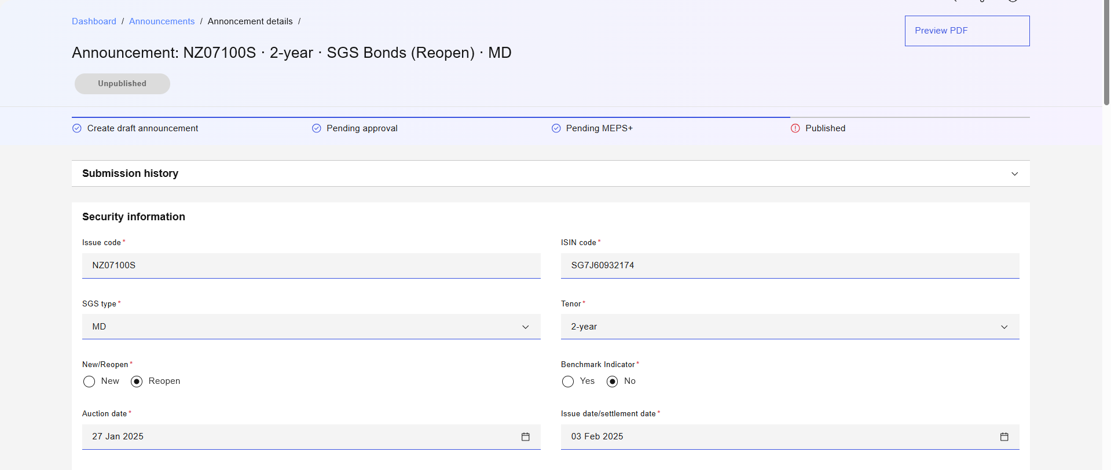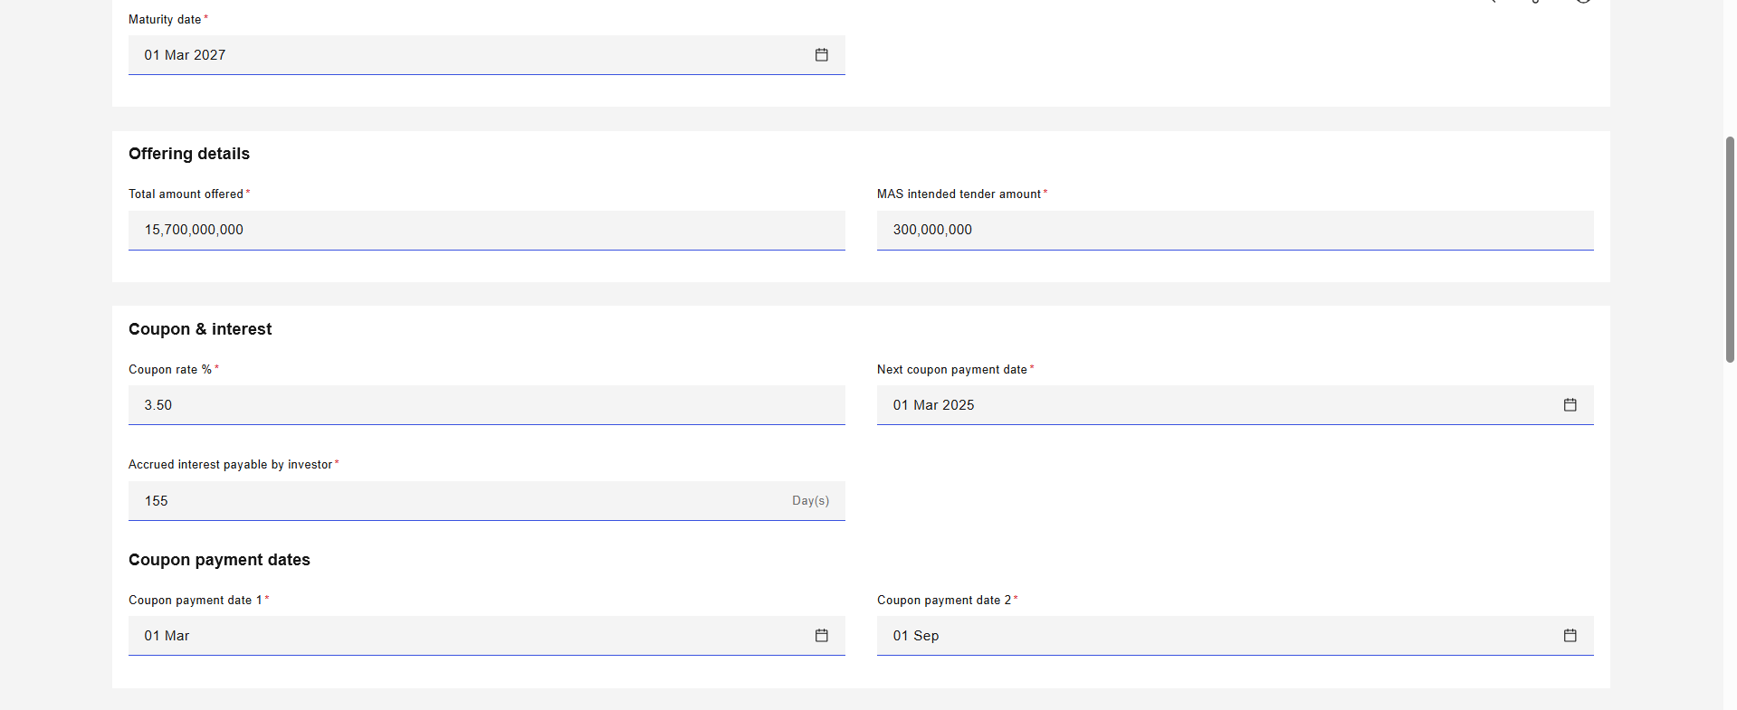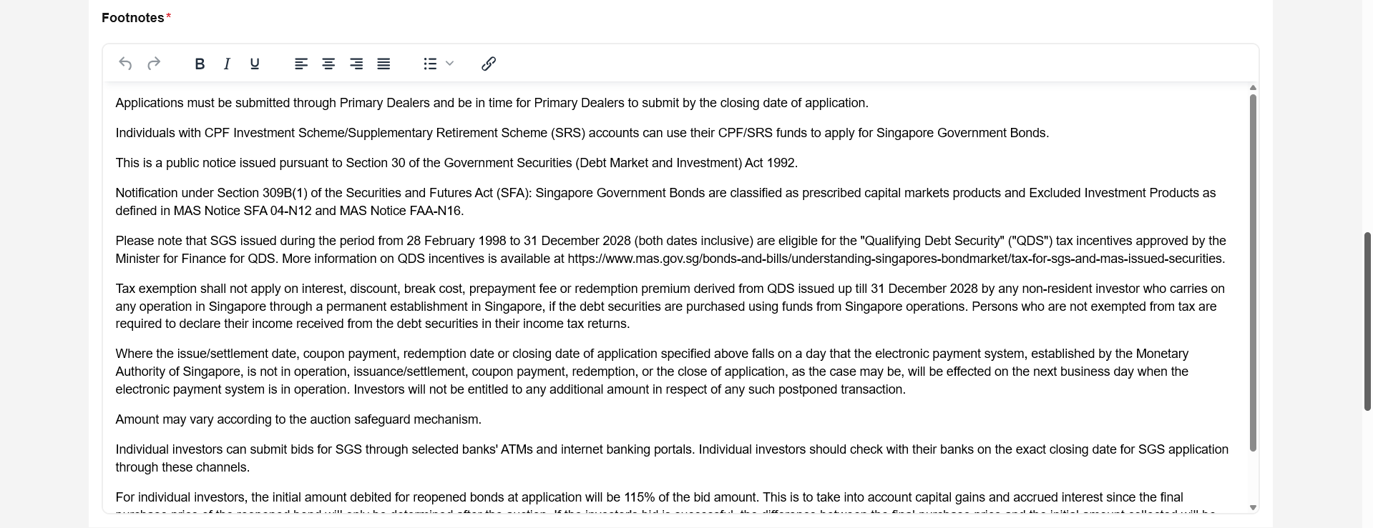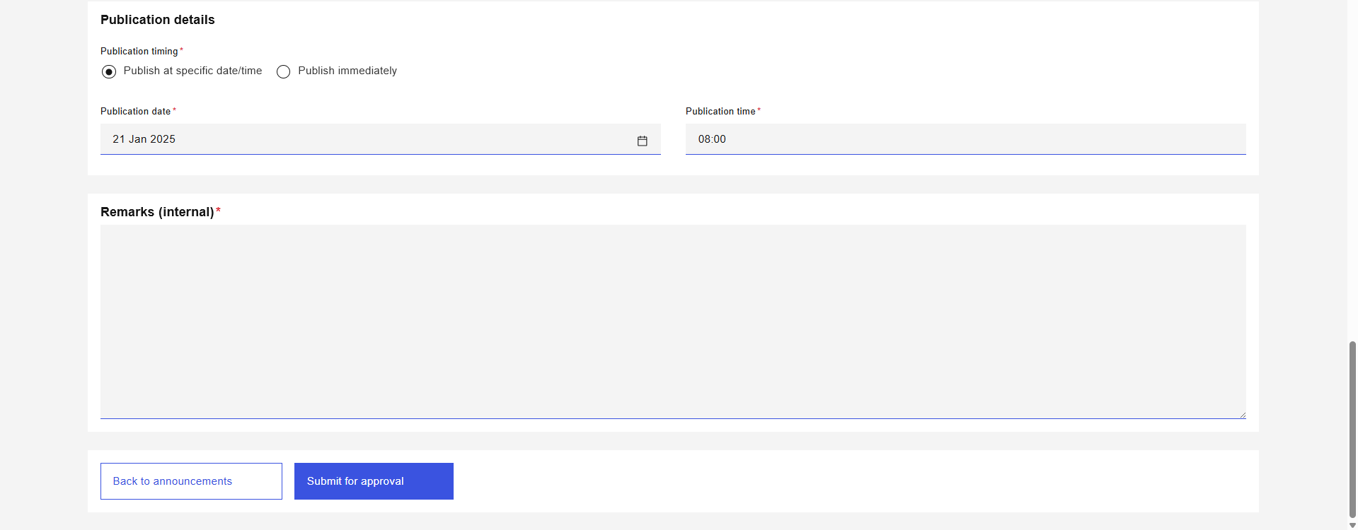
Figure 8: Announcement Details Page (SGS Bonds – Reopened)
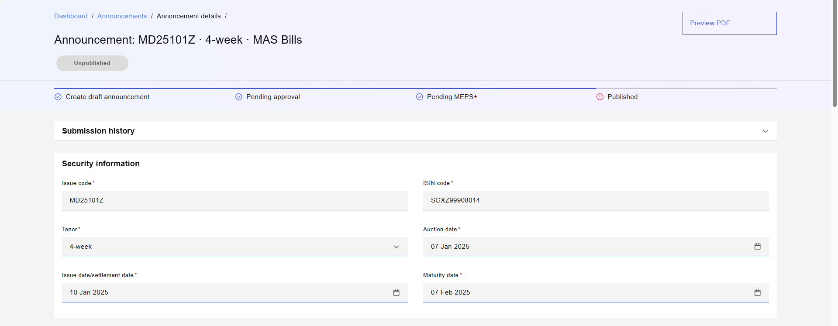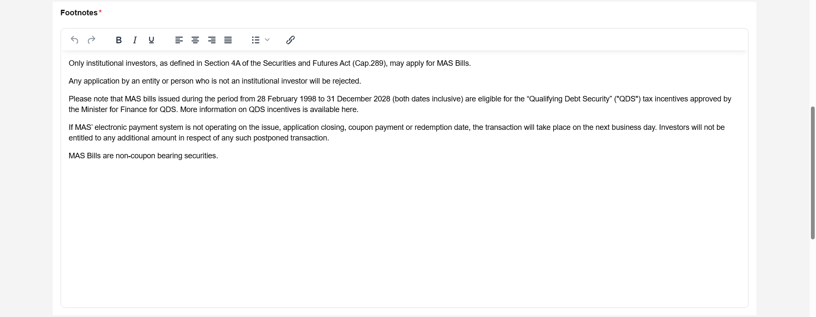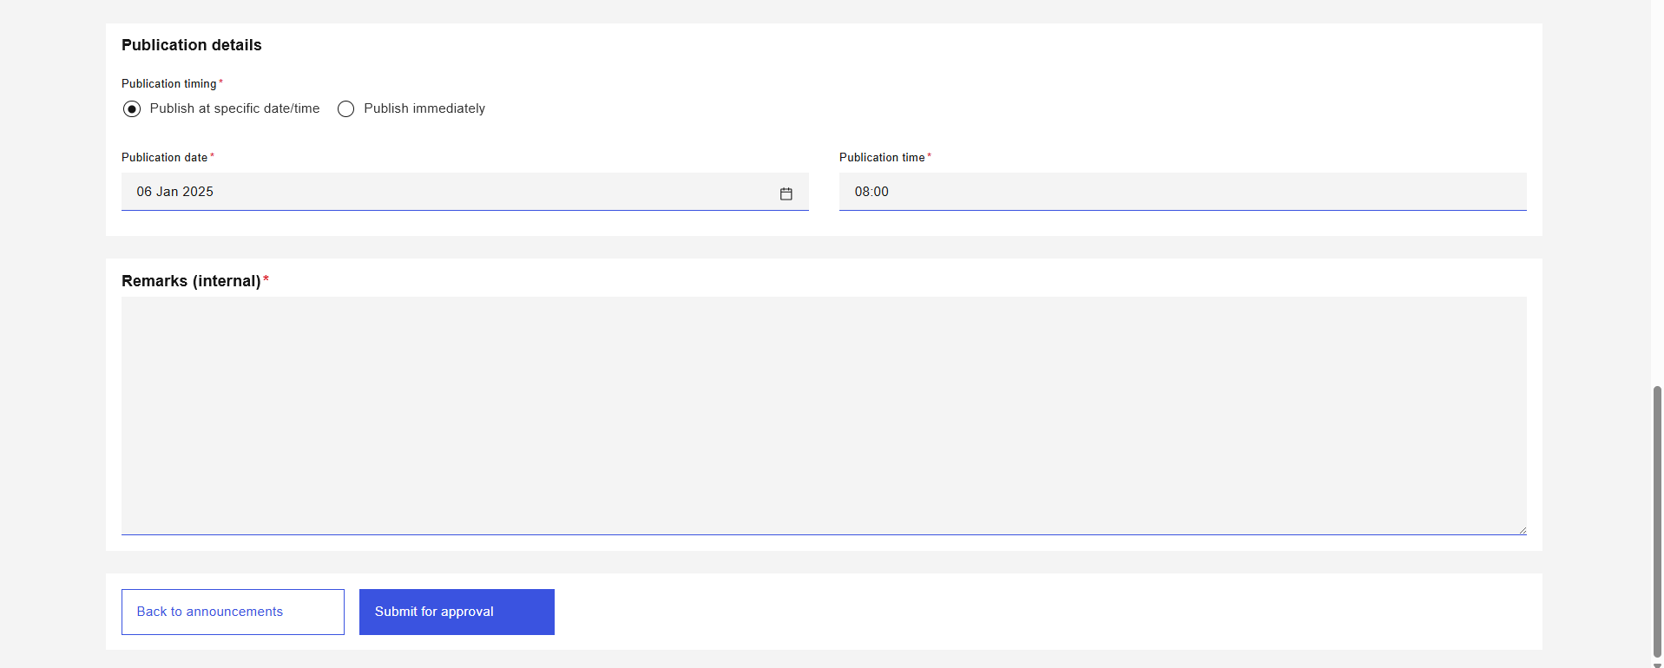
Figure 9: Announcement Details Page (MAS Bills)
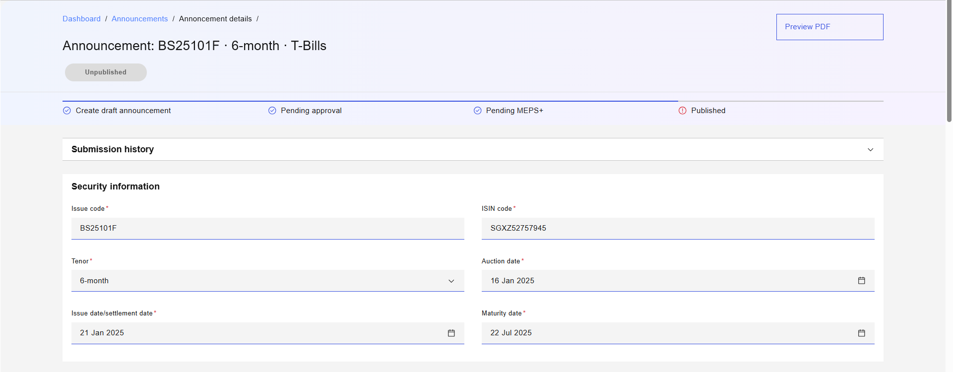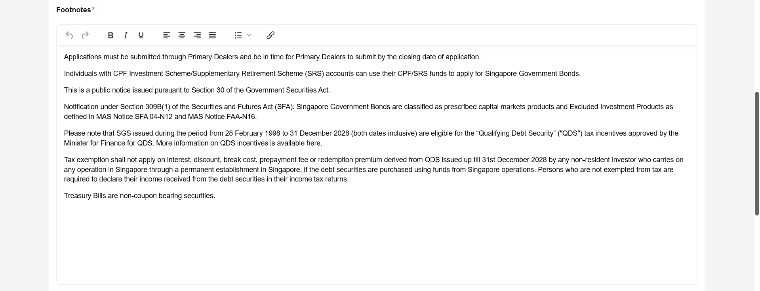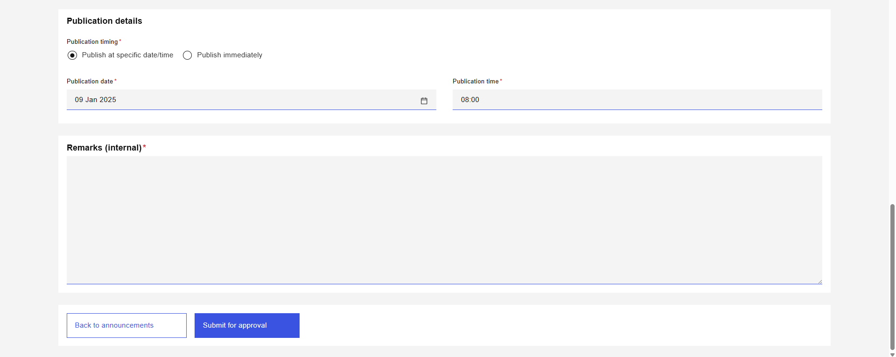
Figure 10: Announcement Details Page (T-Bills)

Page Header
S/N | Name | Type  (Max Length) | Validation Rules | Remarks
1 | Page Title | Page Title |  | Displays the Security type and Issue code of the announcement as “Announcement: {issueCode} ·  {tenor} · {securityType} ({newReopen}) · {sgsType}”; with newReopen and sgsType being relevant only for SGS.  e.g. "Announcement: N525100T·  5-year · SGS Bonds (Re-open) · MD" or "Announcement: GX25090A ·  10-year · SSB".
2 | Status | Status Pill Indicator |  | Displays the status of the announcement. For example, .
3 | Progress Indicator | Progress Indicator |  | Displays the following steps:  - Update announcement  - Pending approval  - Pending MEPS+  - Published  Refer to MAS_OMEGA – Functional Specifications Document (Common Functions).docx for the behaviour of a progress indicator.
Table 7: Page Header Screen Elements

Submission History
Refer to MAS_OMEGA – Functional Specifications Document (Common Functions).docx for the screen elements used and its functionalities.

Security Information
S/N | Name | Type  (Max Length) | Validation Rules | Remarks
1 | Issue code | Text  Max length: 8 | Hard validations:  - Mandatory field.  - Invalid Issue code. | Refer to Logic For Issue Code.pdf for the validation logic.
2 | ISIN code | Text  Max length: 12 | Hard validations:  - Mandatory field.  - For Reopened SGS: Must be same as the ISIN code of the original issue.
3 | SGS type | Dropdown | Hard validations:  - Mandatory field for SGS Bond.  - For Reopened SGS: Must be same as the SGS type of the original issue. | Will show “SGS type” if the security is a SGS Bond, and “Subtype” for created securities with subtypes .  Visible and mandatory if the security is a SGS Bond or has subtypes.  Available options are based on the list of subtypes for the security type.
4 | Tenor | Dropdown | Hard validations:  - Mandatory field. | Available options are based on the list of tenors for the security type.
5 | New/Reopen | Radio Button Group | Hard validations:  - Mandatory field for SGS Bond. | Visible and mandatory if the security is a SGS Bond.  Available options are:  - New  - Reopen
6 | Benchmark | Radio Button Group | Hard validations:  - Mandatory field for SGS Bond. | Visible and mandatory if the security is a SGS Bond.  Available options are:  - Yes  - No
7 | Auction/Allotment date | Date Picker | Hard Validations:  - Mandatory field.  - Must be on or before Issue Date.  Soft Validations:  - Should be {X} business days before Issue date.  - MAS Bills: Should follow the Auction/Allotment date of other tenors issued on the same week.  - Should be a business day. | Will show “Allotment date” for SSB, and “Auction date” for other security types.  {X} is the value of the “Auction day (T-X business days)” parameter for the following security types:  • SGS Bonds  • T-Bills  • MAS Bills  • SSB  Soft validations do not apply to CMTBs.
8 | Issue date | Date Picker | Hard validations:  - Mandatory field.  - Must be before Maturity Date.  Soft validations:  - SGS Bonds and SSBs: Should be on the {X} business day(s) of the month.  - T-Bills and MAS Bills: Should be on {Y}.  - MAS Bills: Should fall on a past Maturity Date of the same tenor.  - Should be a business day. | {X} is the value of the “Primary issue/maturity day (T)” parameter for the following security types:  - SGS Bonds  - SSBs  {Y} is a derivation of the value of the “Primary issue/maturity day (T)” and the “Offset from primary issue day” parameters of following security types:  - T-Bills  - MAS Bills  For example, if the “Primary issue/maturity day (T)” is Friday and the “Offset from primary issue day” is -1, then the Issue date/settlement date should be on a Thursday.
9 | Maturity date | Date Picker | Hard validations:  - Mandatory field.  - Must be same as the Maturity date of the original issue for SGS Bond (Reopened).  Soft validations:  - Should be on the 1st of the same month of the Issue date plus the tenor for SSBs and SGS Bond (New).  - Should fall on {X} for T-Bills.  - Should be a business day for MAS Bills. | {X} is the value of the “Primary issue/maturity day (T)” parameter for the following security types:  - T-bills  - SSBs  - SGS Bond (New)
10 | Closing date | Date Picker | Hard Validations:  - Mandatory field.  - Must be on or before Allotment date.  Soft Validations:  - Should be 1 business day before Allotment Date. | Only visible and mandatory for SSBs and other security types created whose bid collation occurs over the month.
Table 8: Security Information Screen Elements

Offering Details
S/N | Name | Type  (Max Length) | Validation Rules | Remarks
1 | Total amount offered | Text  Max length: 13 | Hard validations:  - Mandatory field.  - Divisible by minimum denomination of the security type with no remainder. | Large denomination shortcut applies for this field. Refer to MAS_OMEGA – Functional Specifications Document (Common Functions).docx for more details.
2 | MAS intended tender amount | Text  Max length: 13 | Hard validations:  - Must be less than Total amount offered.  - Divisible by minimum denomination of the security type with no remainder. | Visible and mandatory if Security type is SGS Bond or T-Bill.  Default value: 0.  Tooltip to display: “If the value is 0,“Nil” will be displayed in the announcement and when published to MAS website.”  Large denomination shortcut applies for this field. Refer to MAS_OMEGA – Functional Specifications Document (Common Functions).docx for more details.
Table 9: Offering Details Screen Elements

Coupon & Interest
S/N | Name | Type  (Max Length) | Validation Rules | Remarks
1 | Step-up coupon rate | Data table | Hard validations:  - Mandatory field for SSB.  - Maximum 2 decimal places. | Visible and mandatory if the security type is SSB.  Initial values are generated by OMEGA. Refer to 6 Step-up Coupon Rate Calculation Logic.  Can be updated using file upload to overwrite the system computed values - refer to 2.8.6 Upload File Modal.
2 | Coupon rate | Text  Max length: 100 | Hard validations:  - Mandatory field for SGS Bond and SSB. | Visible and mandatory if the security type is SSB or SGS Bonds.  Default for SSB: “Per Table 1.”  Default for New SGS Bonds: "To be determined based on the cut-off yield of successful applications"  For Reopened SGS Bonds, obtain the coupon rate of the original issue from the security database table (e.g., “1.657%”).
3 | First coupon payment date | Date Picker | Hard validations:  - Mandatory field for SGS Bond (New) and SSB.  - Must be after issue date | Visible and mandatory if the security type is SSB or SGS Bond (New).  When the status is “New”, the value is pre-populated and computed from coupon payment dates and the coupon payment frequency to find the upcoming coupon payment date after the latest approved issue date.  For example, if the coupon payment dates are 01 Jun and 01 Dec, the issue date is in Jun 2025, and the coupon payment frequency is half-yearly, the first coupon payment date will be on the coupon payment date that is 6 months after the issue date i.e. 01 Dec 2025.
4 | Next coupon payment date | Date Picker | Hard validations:  - Mandatory field for SGS Bond (Reopen).  - Must be after issue date. | Visible and mandatory if the security type is SGS Bond (Reopen).  When the status is “New”, the value is pre-populated and computed from the latest approved maturity date and the coupon payment frequency to determine the coupon payment dates and then finding the upcoming coupon payment date after the latest approved issue date.  For example, if the maturity date is in Jun 2067 and the coupon payment frequency is half-yearly, then the coupon payment dates would be on the 1st calendar day of the month of the maturity day and 6 months before (i.e. 01 Jun and 01 Dec of every year). If the current issue date is before 01 Jun 2025, the next coupon payment date would be 01 Jun 2025. If the current issue date is after 01 June 2025, then the next coupon payment date would be 01 Dec 2025.
5 | Coupon payment dates | Date Picker | Hard validations:  - Mandatory field for SGS Bond and SSB.  - | Visible and mandatory if the security type is SSB or SGS Bond.  This field is in DD MMM (e.g. 01 Jan). While the date picker component includes the year, the value of the year is discarded when selecting dates in this field. For example, even though the user selects the date “26 Dec 2025”, the field should display “26 Dec” and the database should also store the corresponding value without the year.  When the status is “New”, the value is pre-populated and computed from the latest approved maturity date, and the coupon payment frequency of the security type.  For example, if the maturity date is in Jun 2067 and the coupon payment frequency is half-yearly, then the coupon payment dates would be on the 1st calendar day of the month of the maturity day and 6 months before (i.e. 01 Jun and 01 Dec).
6 | Accrued interest payable by investor | Numeric  Max length: 3 | Hard validations:  - Mandatory field for SGS Bonds. | Visible and mandatory if the security type is SGS Bonds.  When the status is New, the value is pre-populated and computed based on the number of days between the previous coupon payment date (which is obtained from the original issue in security table) and the issue date of Reopened SGS Bonds. The value is 0 for New SGS Bonds.
Table 10: Coupon & Interest Screen Elements

Footnotes
S/N | Name | Type  (Max Length) | Validation Rules | Remarks
1 | Footnotes | Rich Text Editor Max length: 4000 | Hard Validations:  - Mandatory field. | Defaults to the parameterised footnote value for the security type, issuance type, and whether the bond is new/reopened.  For SGS bonds, different footnotes are available for each subtype, and there is an addendum that is added for reopened SGS bonds. If a subtype does not have a footnote value set, it will fallback to a default value. Refer to MAS_OMEGA – Functional Specifications Document (Administration).docx.
Table 11: Footnotes Screen Elements

Publication Details
S/N | Name | Type  (Max Length) | Validation Rules | Remarks
1 | Publication timing | Radio Button Group |  | Options available are:  - Publish at specific date/time  - Publish immediately
2 | Publication date | Date Picker |  | To display when “Publish at specific date/time” is selected as the Publication Timing. Mandatory when displayed.  Defaults to current date.  Not displayed when “Publish immediately” is selected as the Publication Timing.
3 | Publication time | Time Picker |  | To display when “Publish at specific date/time” is selected as the Publication Timing. Mandatory when displayed.  Defaults to the parameterised announcement publication timing.  Not displayed when “Publish immediately” is selected as the Publication Timing.
Table 12: Publication Details Screen Elements

Internal Remarks
Refer to MAS_OMEGA – Functional Specifications Document (Common Functions).docx for the screen elements used and its functionalities.

Action Button Row
S/N | Name | Type  (Max Length) | Validation Rules | Remarks
1 | Back | Tertiary button |  | Redirects the user back to the Announcement Listing Page retaining the filters previously selected.
Table 13: Action Button Row Screen Elements

Update Announcements

Description
This use case enables Makers to update announcements.

Preconditions
- User logs in to the Intranet Portal.
- User accesses the Announcement Details Page.
- The announcement is not of the status “Pending Approval”.

Business Requirements
- Role-based Access Control:
  - Announcement Maker

Post Conditions
- An instance of the BPMN workflow is created.
- The status of the announcement is updated to “Pending Approval”.
- The event is added to the audit log and submission history.
- Emails and notifications are sent to the checkers to inform them of the announcement which was submitted for approval.
- User is redirected back to the Announcement Listing Page.
- User views a temporary toast notification informing that the approval request was sent.

Announcement Details Page
Refer to 2.7.6 Announcement Details Page for the screen elements in the Announcement Details page. In this use case, the page contains additional elements in the data table for SSBs only (under Coupon and Interest section) and the Action Button Row.

Wireframe
Refer to 2.7.6.1 Wireframe.

Coupon & Interest
S/N | Name | Type  (Max Length) | Validation Rules | Remarks
1 | Upload rates | Tertiary button |  | Only visible if the step-up coupon rate data table is visible.  Opens the upload file modal.
2 | Export rates | Tertiary button |  | Downloads the existing step-up coupon rates saved in OMEGA for the announcement.  When the status is “New”, the values are generated based on the calculation logic in 6 Step-up Coupon Rate Calculation Logic.
Table 14: Coupon & Interest Screen Elements

Action Button Row
S/N | Name | Type  (Max Length) | Validation Rules | Remarks
1 | Next | Primary button |  | Opens the confirmation prompt.  Disabled if mandatory fields in Announcement Details page are not filled.
Table 15: Action Button Row Screen Elements

Upload Rates File Modal
The following file-level validations apply:
- Check if the file exceeds the file size limit;
- Check if the file is readable as an Excel file;
- Check if the file template matches the template in xxx.

Wireframe
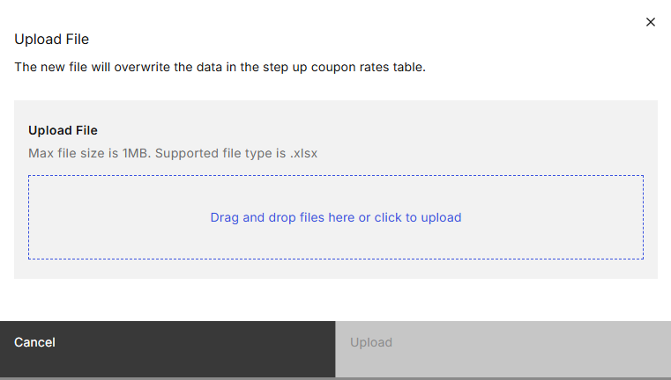
Figure 11: Upload File Modal

Screen Elements
S/N | Name | Type  (Max Length) | Validation Rules | Remarks
1 | Upload rates | Modal title
2 | The new file will overwrite the data in the step-up coupon rates table. | Modal description
3 | Upload rates | File upload container | Hard Validations:  - Mandatory field.
4 | Cancel | Secondary button |  | Closes the Upload File Modal.
5 | Upload | Primary button |  | Clicking this button overwrites the existing data in the step-up coupon rates table with the data from the uploaded file.  Disabled if there is no input in the mandatory field.
Table 16: Upload File Modal Screen Elements

Confirmation Prompt

Wireframe
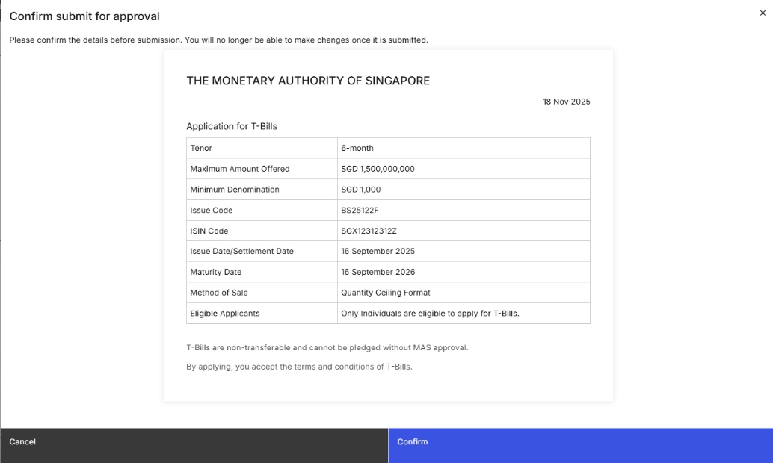
Figure 12: Confirmation Prompt

Screen Elements
S/N | Name | Type  (Max Length) | Validation Rules | Remarks
1 | Confirm submission | Modal title
2 | Please confirm the details before submitting for approval.  Note: Any changes will not be reflected in the issuance calendar. If necessary, please update the calendar separately. | Modal description
3 | *Refer to remarks | PDF Preview |  | Displays a preview of the PDF announcement that will be generated upon publication based on the existing values of the form.  For the fields displayed in the PDF preview, refer to 7 Fields for PDF Previews.
4 | Cancel | Secondary button |  | Closes the confirmation prompt.
5 | Submit | Primary button |  | Submits the updated announcement for approval. Refer to 2.8.4 Post Conditions.
Table 17: Confirmation Prompt Screen Elements

Withdraw Announcement Approval Request

Description
This use case enables Makers to withdraw announcement updates or withdraw unpublished request from approval. This is typically used when approval for the announcements is not required at the point in time i.e., there are further updates to be made to the announcement, or the updates that were submitted for approval are no longer required.

Preconditions
- User logs in to the Intranet Portal.
- User accesses the Announcement Details Page.
- The announcement is of the status “Pending Approval”.

Business Requirements
- Role-based Access Control:
  - Announcement Maker

Post Conditions
- The instance of the BPMN workflow that was created when the announcement was submitted for approval is suspended.
- The status of the announcement is updated based on its previous status, refer to 2.5 State Transition Diagram.
- The event is added to the audit log and submission history.
- Emails are sent to the checkers to inform them of the announcement which was withdrawn.
- User is redirected back to the Announcement Listing Page.
- User views a temporary toast notification informing that the withdrawal was successful.

Announcement Details Page
Refer to 2.7.6 Announcement Details Page for the screen elements in the Announcement Details page. In this use case, the page contains additional elements in the Page Header.

Wireframe
Refer to 2.7.6.1 Wireframe.

Page Header
S/N | Name | Type  (Max Length) | Validation Rules | Remarks
1 | Withdraw | Tertiary button |  | Opens the confirmation prompt.
Table 18: Page Header Screen Elements

Confirmation Prompt

Wireframe
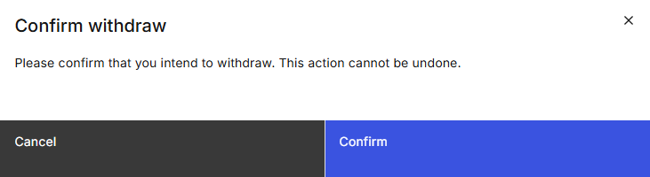
Figure 13: Confirmation Prompt

Screen Elements
S/N | Name | Type  (Max Length) | Validation Rules | Remarks
1 | Confirm withdrawal | Modal title
2 | Please confirm that you intend to withdraw the request. This action cannot be undone. | Modal description
3 | Cancel | Secondary button |  | Closes the confirmation prompt.
4 | Confirm | Primary button |  | Withdraws the approval request submitted for this announcement.  Refer to 2.9.4 Post Conditions.
Table 19: Confirmation Prompt Screen Elements

Approve/Reject Announcement/Unpublish Announcement

Description
This use case enables Checkers to approve or reject announcements or retraction of announcements from website. This is typically used when the announcement is ready to be published to the MAS Website depending on the publication time chosen.

Preconditions
- User logs in to the Intranet Portal.
- An announcement was updated or unpublished by a Maker and submitted for approval.
- The announcement is of the status “Pending Approval”.
- User accesses the Announcement Details Page.

Business Requirements
- Role-based Access Control:
  - Announcement Checker
- Checkers are not allowed to approve or reject the announcements/retraction of announcements which they have submitted for approval, as they may hold both maker and checker roles.
- Checkers must enter remarks before being able to reject the announcement/retraction of announcement.
- If Checkers approve the announcement after the set publication date/time, the announcement is published immediately.
- Snapshot of Configuration on First Approval: On first approval by Checkers, a snapshot of the configuration values and static text that are used as part of the PDF preview and the information to be sent to the MAS website is taken. These values will not be changed on subsequent changes (i.e., edits, withdrawals, approvals, or rejections) to the announcement. Any changes required to the configuration values after first approval, must be done by a data patch only. Refer to 3 Other Announcement Fields Not In UI for a list of these values.

Post Conditions
- The announcement is either:
  - approved and will be awaiting information from MEPS+ via secmast.txt and couponrates_sbond.txt, OR
  - approved and will be unpublished from the MAS website, OR
  - rejected and reverted to its previous status (if the previous status is not “Pending MEPS+”, “Pending Publication” or “Rejected”), OR
  - rejected and its status is changed to “Rejected” (if the previous status is “Pending MEPS+”, “Pending Publication” or “Rejected”).
- If the information from MEPS+ is successfully validated and the announcement is not in status “Unpublished”, on the set publication date/time, OMEGA sends the approved announcement details to the MAS Website. Refer to the MAS_OMEGA – Interface Specifications Document (MAS Website).docx for more details. Emails are also sent upon publication of the announcement.
- Emails are sent to inform users that the announcement has been approved or rejected.
- User views a temporary toast notification informing that the approval or rejection was successful.

Announcement Details Page
If the step-up coupon rates are amended from the OMEGA-generated values or previously approved values, the checker sees both the current and previous coupon rates. The current amended rates are displayed as part of the data table cell, while the previous rates are displayed below in blue ().
For unpublish requests, the page contains an additional banner indicating that the request is to unpublish the announcement. Refer to 2.10.7 Unpublish Banner.

Wireframe
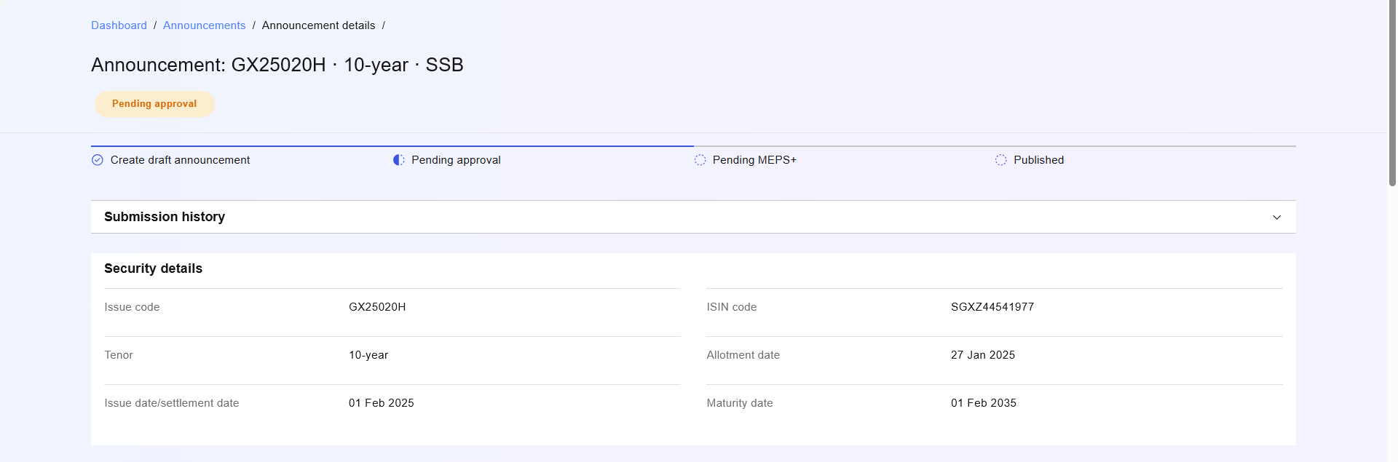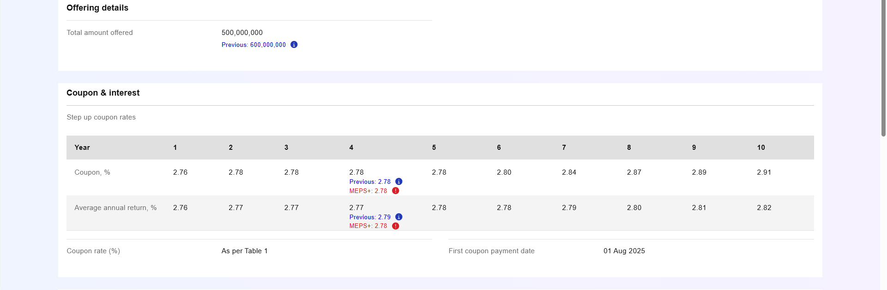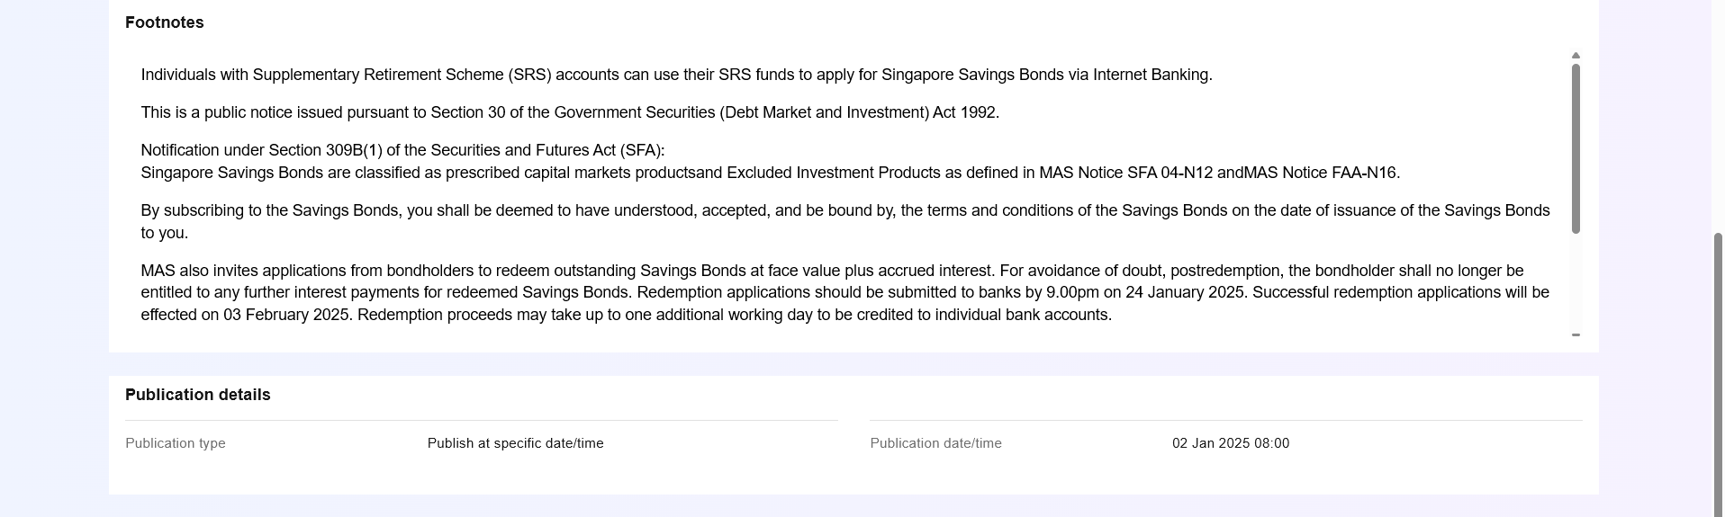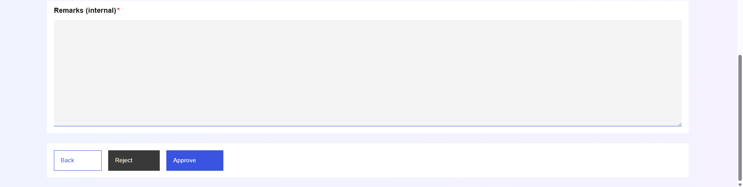
Figure 14: Announcement Details Page (for updates)

Action Button Row
S/N | Name | Type  (Max Length) | Validation Rules | Remarks
1 | Reject | Secondary button |  | Opens the confirmation prompt.  Disabled if the Checker is also a Maker that submitted the request to update or unpublish the announcement for approval.
2 | Approve | Primary button |  | Opens the confirmation prompt.  Disabled if the Checker is also a Maker that submitted the request to update or unpublish the announcement for approval.
Table 20: Action Button Row Screen Elements

Confirmation Prompt

Wireframe
Figure 15: Confirmation Prompt Modal

Screen Elements
S/N | Name | Type  (Max Length) | Validation Rules | Remarks
1 | *Refer to remarks | Modal title |  | When the “Reject” button is clicked, “Confirm rejection” is displayed.  If the “Approve” button is clicked, “Confirm approval” is displayed.
2 | *Refer to remarks | Modal description |  | When the “Reject” button is clicked, “Please confirm the details before rejecting the request to {update/unpublish} this announcement.” is displayed.  If the “Approve” button is clicked, “Please confirm the details before approving the request to {update/unpublish} this announcement.” is displayed.
3 | *Refer to remarks | PDF Preview |  | Displays a preview of the PDF announcement that will be generated upon publication based on the existing values of the form.  For the fields displayed in the PDF preview, refer to 7 Fields for PDF Previews.
4 | Cancel | Secondary button |  | Closes the confirmation prompt
5 | Confirm | Primary button |  | Approves the update or unpublish request that was submitted for approval. Refer to 2.10.4 Post Conditions.
Table 21: Confirmation Prompt Screen Elements

Unpublish Banner
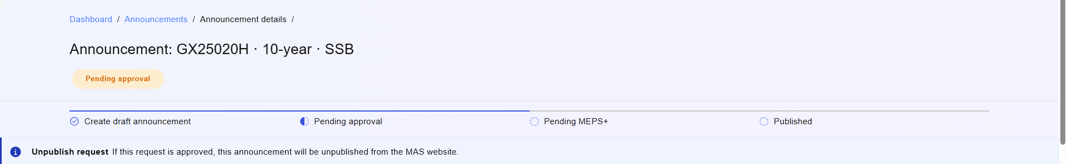
Figure 16: Unpublish Banner (displayed under the Page Header)

Screen Elements
S/N | Name | Type  (Max Length) | Validation Rules | Remarks
1 | Unpublish request | Banner title
2 | If this request is approved, this announcement will be unpublished from the MAS website. | Banner description

Unpublish Announcement

Description
This use case enables Makers to request for announcements to be unpublished. This is typically used when the announcement is published to the MAS website and must be unpublished. The request must be approved by a Checker before the announcement is unpublished from the MAS website.

Preconditions
- User logs in to the Intranet Portal.
- User accesses the Announcement Details Page.
- The announcement is of the status “Published”.

Business Requirements
- Role-based Access Control:
  - Announcement Maker

Post Conditions
- An instance of the BPMN workflow is created.
- The status of the announcement is updated to “Pending Approval”.
- The event is added to the audit log and submission history.
- Emails are sent to the checkers to inform them of the announcement which was requested to be unpublished.
- User is redirected back to the Announcement Listing Page.
- User views a temporary toast notification informing that the unpublish request was sent.

Announcement Details Page
Refer to 2.7.6 Announcement Details Page for the screen elements in the Announcement Details page. In this use case, the page contains additional elements in the Page Header.

Wireframe
The wireframe below only includes the changes in the Page Header. For other sections in the Announcement Details page,
refer to 2.7.6.1 Wireframe.
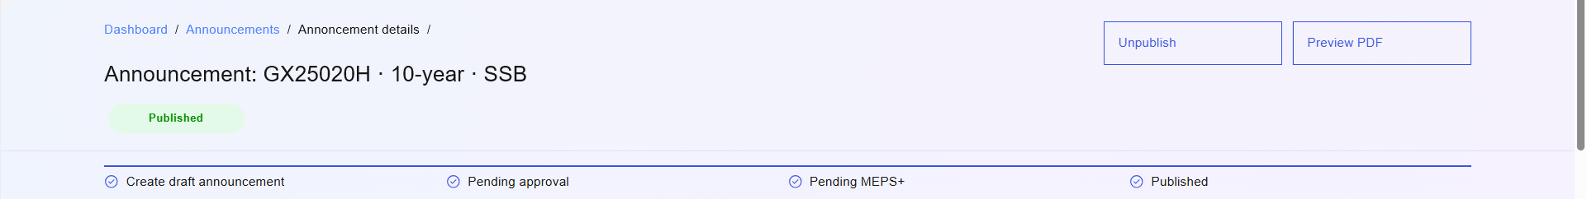
Figure 17: Page Header

Screen Elements
S/N | Name | Type  (Max Length) | Validation Rules | Remarks
1 | Unpublish | Tertiary button |  | Opens the confirmation prompt.
Table 22: Page Header Screen Elements

Confirmation Prompt

Wireframe
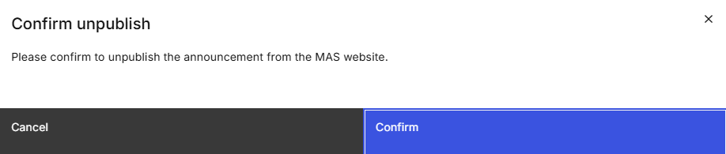
Figure 18: Confirmation Prompt

Screen Elements
S/N | Name | Type  (Max Length) | Validation Rules | Remarks
1 | Confirm submission | Modal Title
2 | Please confirm before submitting for approval. | Modal Description
3 | Cancel | Secondary button |  | Closes the confirmation prompt.
4 | Submit | Primary button |  | Unpublishes the announcement from the MAS website. Refer to 2.11.4 Post Conditions.
Table 23: Confirmation Prompt Screen Elements

Override MEPS+ Validation Error

Description
This use case enables Checkers to override any validation errors between MEPS+ and the announcement data in OMEGA. This is typically used when there is a discrepancy between the announcement data in OMEGA and the data from secmast.txt file, and the data from MEPS+ is determined to be correct.

Preconditions
- User logs in to the Intranet Portal.
- User accesses the Announcement Details Page.
- The announcement is of the status “MEPS+ Validation Error”.

Business Requirements
- Role-based Access Control:
  - Announcement Checker

Post Conditions
- The announcement is updated with the values provided from MEPS+.
- User views a temporary toast notification informing that the override was successful.
- The status of the announcement is updated to “Pending Publication” and is published immediately or at the scheduled publication time, whichever is later.
- The event is added to the audit log and submission history.
- At the scheduled publication date/time, OMEGA sends the approved announcement details to the MAS Website. Refer to the MAS_OMEGA – Interface Specifications Document (MAS Website).docx for more details.
- Emails will be sent upon publication of the announcement.
- As issuance calendar and announcement are decoupled upon first submission by Announcement maker, the issuance calendar has to be updated manually where necessary to ensure data synchronization.

Announcement Details Page
Refer to 2.7.6 Announcement Details Page for the screen elements in the Announcement Details page. In this use case, the page will contain additional elements in the Action Button Row.

Wireframe
Refer to 2.7.6.1 Wireframe.

Action Button Row
S/N | Name | Type  (Max Length) | Validation Rules | Remarks
1 | Override | Primary button |  | Opens the confirmation prompt.
Table 24: Action Button Row Screen Elements

Confirmation Prompt

Wireframe
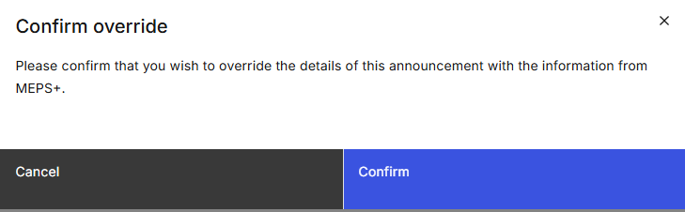
Figure 19: Confirmation Prompt Modal

Screen Elements
S/N | Name | Type  (Max Length) | Validation Rules | Remarks
1 | Confirm override | Modal Title
2 | Please confirm that you wish to override the details of this announcement with the information from MEPS+.  Note: Any changes will not be reflected in the issuance calendar. If necessary, please update the calendar separately. | Modal Description
3 | Confirm | Primary button |  | Overrides the announcement details with the information from MEPS+. Refer to 2.12.4 Post Conditions.
Table 25: Confirmation Prompt Screen Elements

Preview PDF

Description
This use case enables Viewers, Makers, and Checkers to preview and download the announcement PDF to visualise the file that is generated based on the existing announcement data stored in OMEGA.

Preconditions
- User logs in to the Intranet Portal.
- User accesses the Announcement Details Page.
- The announcement is of the status “Pending Publication”, “Published”, “Unpublished”.

Business Requirements
- Role-based Access Control:
  - Announcement Viewer
  - Announcement Maker
  - Announcement Checker

Post Conditions
- User remains in the Announcement Details Page.
- The Preview PDF Modal is opened.

Announcement Details Page
Refer to 2.7.6 Announcement Details Page for the screen elements in the Announcement Details page. In this use case, the page contains additional elements in the Page Header.

Wireframe
Refer to 2.7.6.1 Wireframe.

Page Header
S/N | Name | Type  (Max Length) | Validation Rules | Remarks
1 | Preview PDF | Tertiary button |  | Opens the Preview PDF Modal.
Table 26: Page Header Screen Elements

Preview PDF Modal

Wireframe

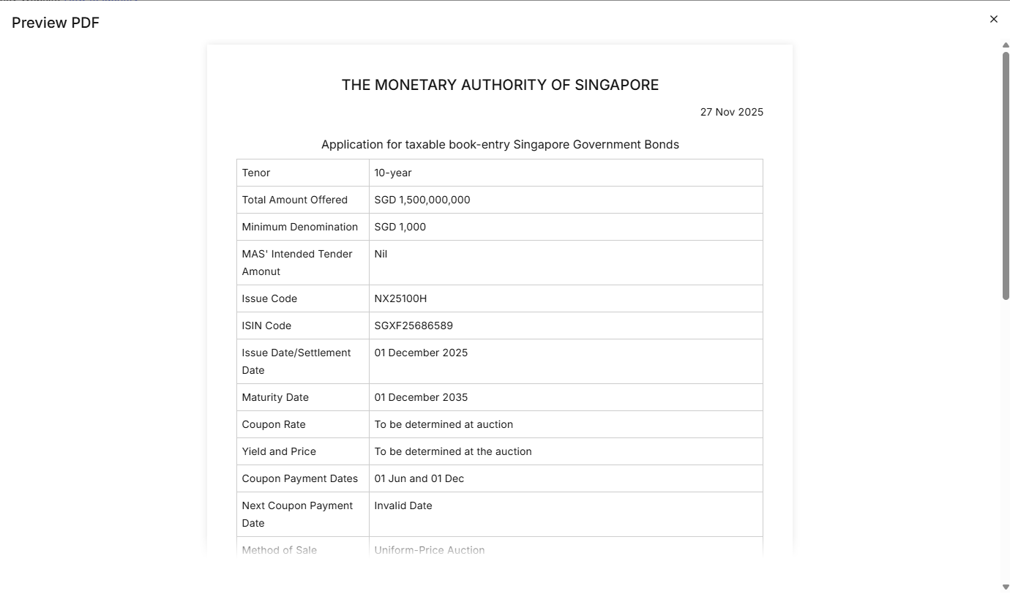
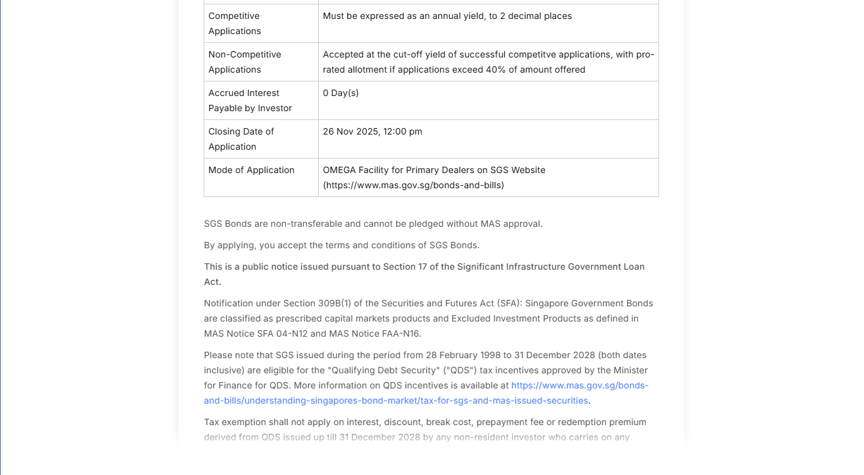

Figure 20: Preview PDF Modal

Screen Elements
The preview makes use of the in-browser feature to render the PDF and allow for download.
S/N | Name | Type  (Max Length) | Validation Rules | Remarks
1 | Preview PDF | Modal Title
2 | *Refer to remarks | PDF Preview |  | Displays a preview of the PDF based on the data stored in OMEGA database.  For the list of fields viewable in the PDF, refer to 7 Fields for PDF Previews.

Table 27: Preview PDF Screen Elements

Sample Files
Refer to the attachments below which serves to illustrate how the PDF preview will differ based on each security type when viewed in the modal and when downloaded as a file.

Other Announcement Fields Not In UI
There are other fields that form part of the PDF preview and are to be published to MAS website. These fields can be configurable parameters or static text that are not configurable via the Administration module:

Fields Based on Configurable Parameters

- Minimum Denomination

- Method of Sale

- Closing Date of Application
- Individual Holdings Limit across all Savings Bonds
- Closing Date of Application for Individuals
The values of these fields are set based on security type. For more information, refer to MAS_OMEGA – Functional Specifications Document (Administration).docx.

Fields Based on Static Text
- Heading Title
- Date
- Heading Details
- Yield and Price
- Competitive Applications
- Non-Competitive Applications
- Eligible Applicants
For the heading title, it will always be “THE MONETARY AUTHORITY OF SINGAPORE”. The date will always be the date the announcement is published or is scheduled to be published. The values of other fields are set based on security type as shown in the table below:
Announcement Field Name | SSB | SGS Bond  (Reopen) | SGS Bond  (New) | MAS Bills | T-Bills | CMTB
Heading Details | Application for Singapore Savings Bonds ("Savings Bonds") | Application for taxable book-entry Singapore Government Bonds | Application for taxable book-entry Singapore Government Bonds | Application for taxable book-entry MAS Bills | Application for taxable book-entry Singapore Government Treasury Bills | Application for taxable book-entry Cash Management Treasury Bills
Yield and price |  | To be determined at the auction | To be determined at the auction | To be determined at the auction | To be determined at the auction | To be determined at the auction
Competitive Applications |  | Must be expressed as an annual yield, to 2 decimal places | Must be expressed as an annual yield, to 2 decimal places | Must be expressed as an annual yield, to 2 decimal places | Must be expressed as an annual yield, to 2 decimal places | Must be expressed as an annual yield, to 2 decimal places
Non-Competitive Applications  X is a configurable parameter. |  | Accepted at the cut-off yield of successful competitive applications, with pro-rated allotment if applications exceed X% of amount offered. | Accepted at the cut-off yield of successful competitive applications, with pro-rated allotment if applications exceed X% of amount offered. |  | Accepted at the cut-off yield of successful competitive applications, with pro-rated allotment if applications exceed X% of amount offered.
Eligible Applicants | Only natural persons ("Individuals") are eligible to apply for Savings Bonds.

Daily Announcement Email
Every day at 08:00 (pre-configured), from the issuance calendar data for all security types, OMEGA retrieve the list of issue codes, whose announcement date falls on that day. If there is at least one announcement for that day, OMEGA then sends a daily announcement email of these issuances to remind users.
For more information on the contents of the email, refer to MAS_OMEGA – Additional Information (System Notifications and Emails).xlsx.

Validations Against MEPS+
When processing the secmast.txt and couponrates_sbond.txt files from MEPS+, OMEGA compares the processed data against any announcements that are of the status “Pending MEPS+” or “MEPS+ Validation Error”. In the table below, the first column indicates the announcement fields in OMEGA. The values in the second to the last columns contain the fields in secmast.txt or couponrates_sbond.txt, if any, that would be validated against the corresponding announcement fields in OMEGA.
Only the Step-Up Coupon Rates field is validated against couponrates_sbond.txt. For all other fields, they are validated against secmast.txt.
OMEGA Field Name | SSB | SGS Bond  (Reopen) | SGS Bond  (New) | MAS Bills | T-Bills | CMTB
Tenor | TENOR | TENOR | TENOR | TENOR | TENOR | TENOR
Total Amount Offered | QTY_OFFERED | QTY_OFFERED | QTY_OFFERED | QTY_OFFERED | QTY_OFFERED | QTY_OFFERED
Minimum Denomination
MAS' Intended Tender Amount |  | MAS_APPLIED | MAS_APPLIED |  | MAS_APPLIED
Issue Code | ISSUE_CODE | ISSUE_CODE | ISSUE_CODE | ISSUE_CODE | ISSUE_CODE | ISSUE_CODE
ISIN Code | ISIN_CODE | ISIN_CODE | ISIN_CODE | ISIN_CODE | ISIN_CODE | ISIN_CODE
Auction/Allotment Date  As with the Announcement Details Page, show “Allotment Date” for SSB, and “Auction Date” for other security types. | TENDER_DATE | TENDER_DATE | TENDER_DATE | TENDER_DATE | TENDER_DATE | TENDER_DATE
Issue Date/Settlement Date | ISSUE_DATE | ISSUE_DATE | ISSUE_DATE | ISSUE_DATE | ISSUE_DATE | ISSUE_DATE
Maturity Date | MATURITY_DATE | MATURITY_DATE | MATURITY_DATE | MATURITY_DATE | MATURITY_DATE | MATURITY_DATE
Coupon Rate |  | INT_RATE
Yield and Price
Coupon Payment Dates | INT_DATE1 and INT_DATE2 | INT_DATE1 and INT_DATE2 | INT_DATE1 and INT_DATE2
Next Coupon Payment Date |  | NEXT_INT_DATE
First Coupon Payment Date | NEXT_INT_DATE |  | NEXT_INT_DATE
Method of Sale
Competitive Applications
Non-Competitive Applications
Eligible Applicants
Accrued Interest Payable by Investor |  | ACCRUED_INT_DAYS
Closing Date of Application
Individual Holdings Limit across all Savings Bonds
Closing Date of Application for Individuals
Step Up Coupon Rates | YEAR_NUMBER and COUPON_RATE*
Footnotes
*For SSBs, the year number and the coupon rate in couponrates_sbond.txt must match the coupon rate for the corresponding year in the step-up coupon rates data table of the announcement.

Tenor Validation

Tenor in Days to Weeks
- If the Tenor in Days is between ((4*7)-5) AND ((4*7)+5), then '4-week'
- If the Tenor in Days is between ((8*7)-5) AND ((8*7)+5) , then '8-week'
- If the Tenor in Days is between ((12*7)-5) AND ((12*7)+5) , then '12-week'
- If the Tenor in Days is between ((24*7)-5) AND ((24*7)+5) , then '24-week'
- If the Tenor in Days is between ((36 * 7)-5) AND ((36 * 7)+5) , then '36-week'

Tenor in Days to Month/year
- If the Tenor in Days is between 83 and 97 then ‘3-month’
- If the Tenor in Days is between 178 and 186 then ‘6-month’
- If the Tenor in Days is between 358 and 370 then ‘1-year’

Step-up Coupon Rate Calculation Logic
The logic below described the logic to calculate the step-up coupon rates for SSBs.
- Obtain the 1, 2, 5, and 10-year benchmark SGS yields as reference by retrieving the simple average of the respective daily SGS benchmark yields from the month before the public notice of issuance.

- Calculate the reference SGS yields for the tenors in between the benchmark yields (i.e. 3, 4, 6, 7, 8, 9-year) by interpolating using a Cubic Hermite spline function. The Cubic Hermite spline function is a method to estimate values between two known data points using Cubic Hermite spline interpolation. This ensures smooth transitions by considering both the values and the slopes (tangents) at the endpoints, rather than relying on simple linear interpolation. The spline function can be written using the formula:
pt= h00tp0+ h10tm0+ h01tp1+ h11th∙m1

where:
  - t is the local coordinate in [0,1]
  - h is the segment length (x₁ - x₀)
  - p₀, p₁ are the endpoint values (y[i], y[i+1])
  - m₀, m₁ are the tangents at the endpoints (m[i], m[i+1])
  - The Hermite basis functions are:
    - h₀₀(t) = 2t³ - 3t² + 1
    - h₁₀(t) = t³ - 2t² + t
    - h₀₁(t) = -2t³ + 3t²
    - h₁₁(t) = t³ - t²

Substituting these in gives the complete equation:
p(t) = (2t³ - 3t² + 1)p₀ + (t³ - 2t² + t)h·m₀ + (-2t³ + 3t²)p₁ + (t³ - t²)h·m₁
  - The below calculation is a sample which assumes to interpolate at x = 0.5 where the segment ‘i’ is 0. The actual interpolation for OMEGA occurs on x = 3, 4, 6, 7, 8, and 9 which are non-benchmark tenors.
  - Consider x₀ = 0 and x₁ = 2.
  - The segment length (h) calculated as x[i+1] – x[i] = x[1] – x[0] = 2 – 0 = 2
  - Normalize local co-ordinates (t) calculated as x-x0h= 0.5-02=0.25
  - To calculate the Hermite basis function, OMEGA calculates t² and t³
    - t² = (0.25)² = 0.0625
    - t³ = (0.25)³ = 0.015625
  - OMEGA calculates the:
    - initial position (starting point value) y[i] -> h₀₀ = 2t³ – 3t² + 1 = 0.84375
    - tangent basis at the start m[i] -> h₁₀ = t³ – 2t² + t = 0.140625
    - position at ending point y[i + 1] -> h₀₁ = -2t³ + 3t² = 0.15625
    - tangent basis at the end m[i + 1] -> h₁₁ = t³ – t² = -0.046875
  - Based on the above calculation, interpolation value will be derived as:
    - Assumptions – Position at P₀ = 1 and P₁ = 4
    - Assume tangent at m₀ = 0.5 and m₁ = 1.0
    - Interpolation at x = 0.5:
- P(0.5) = set scale₂₀ of (h₀₀*P₀ + h₁₀*h*m₀ + h₀₁*P₁ + h₁₁*h*m₁)
- ≈ rounding off scale₂₀(1.515625)
- = 1.51562500000000000000 (rounded to 20 decimal places for precision)
- For each year of the SSB tenor,
  - Calculate the discount factor using the formula:
$$DFn = \frac{1 - Yn(DF1 + ⋯+ DFn-1)}{1 + Yn}$$
  - Calculate the coupon rate using the formula:
$$Cn = \frac{1 - DF1(C1) - ⋯ - DFn-1(Cn-1)}{DFn}-1$$
  - If the coupon rate does not allow for a step up, derive the adjusted coupon rate by minimising the sum of the squared errors such that the variables: C₁, C₂, ..., C₁₀ (coupon rates) and e₁, e₂, ..., e₁₀ (error terms) meets the following constraints:
    - Non-decreasing coupon rates: Cₜ ≥ Cₜ₋₁
    - Exact constraint: e₁₀ = 0
    - Non-negative errors: eₜ ≥ 0 for t ∈ [1,9]
  - Round the coupon rate/adjusted coupon rate to 2 decimal places in percentage terms. For example, if the coupon rate/adjusted coupon rate is 0.02058, it will be rounded to 2.06.
- Calculate the average annual compounded yield for each year based on the rounded value of the coupon rate/adjusted coupon rate using the following formula:

cn=C1+…+Cnn
where n is the year number and C is the coupon rate/adjusted coupon rate calculated in Step 3d.

Fields for PDF Previews
The PDF preview will display the fields in the order below:
OMEGA Field Name | SSB | SGS Bond  (Reopen) | SGS Bond  (New) | MAS Bills | T-Bills | CMTB
Heading Details | Yes | Yes | Yes | Yes | Yes | Yes
Tenor | Yes  [To prefix with “Approximately”] | Yes  [To prefix with “Approximately”] and [To suffix with “(non-benchmark)” if Benchmark indicator is No] | Yes  [To prefix with “Approximately”] and [To suffix with “(non-benchmark)” if Benchmark indicator is No] | Yes | Yes | Yes
Total Amount Offered | Yes | Yes | Yes | Yes | Yes | Yes
Minimum Denomination | Yes | Yes | Yes | Yes | Yes | Yes
MAS' Intended Tender Amount | No | Yes | Yes | No | Yes | No
Issue Code | Yes | Yes  [To suffix with “(Reopened)”] | Yes | Yes | Yes | Yes
ISIN Code | Yes | Yes | Yes | Yes | Yes | Yes
Auction/Allotment Date  Note: As with the Announcement Details Page, show “Allotment Date” for SSB, and “Auction Date” for other security types. | Yes | Yes | Yes | Yes | Yes | Yes
Issue Date/Settlement Date | Yes | Yes | Yes | Yes | Yes | Yes
Maturity Date | Yes | Yes | Yes | Yes | Yes | Yes
Coupon Rate | Yes | Yes | Yes | No | No | No
Yield and Price | No | Yes | Yes | Yes | Yes | Yes
Coupon Payment Dates | Yes | Yes | Yes | No | No | No
Next Coupon Payment Date | No | Yes | No | No | No | No
First Coupon Payment Date | Yes | No | Yes | No | No | No
Method of Sale | Yes | Yes | Yes | Yes | Yes | Yes
Competitive Applications | No | Yes | Yes | Yes | Yes | Yes
Non-Competitive Applications | No | Yes | Yes | No | Yes | No
Eligible Applicants | Yes | No | No | No | No | No
Accrued Interest Payable by Investor | No | Yes | Yes | No | No | No
Closing Date of Application | No | Yes | Yes | Yes | Yes | Yes
Individual Holdings Limit across all Savings Bonds | Yes | No | No | No | No | No
Closing Date of Application for Individuals | Yes | No | No | No | No | No
Step Up Coupon Rates | Yes | No | No | No | No | No
Footnotes | Yes | Yes | Yes | Yes | Yes | Yes
For newly created security types, the PDF preview will display the fields based on the original security type they were created from.

